PAYROLL MANAGEMENT SYSTEM PROJECT REPORT

Payroll Management System Project Abstract
The "Payroll Management System" is designed to automate the existing manual system using computerized equipment and cutting-edge computer software, meeting client's needs so that their valuable data and information can be stored for a longer period with easy access and manipulation. The necessary software is readily available and simple to use. This software allows users to keep track of and see computerized records without having to make duplicate entries. The project explains how to handle user data for optimal efficiency and better customer service.

The payroll management system is a web-based program that can be used by any firm to manage the records of its employees. The Payroll Application was created with the goal of keeping track of numerous employees, their allowances, and deductions that must be given to the company's employees. There will be an entry (a unique ID) for every employee of any company. The number of days will be submitted based on the date of joining and the date on which the salary is produced. Basic compensation will be determined by the employee's position and department.

Payroll Management System Project Proposal

Problem Statement: Payroll is usually the most expensive part of a business. Employee attendance systems that use paper sheets are inefficient and make it very easy for employees to cheat the system by entering incorrect data on the sheet. To avoid the aforementioned issues, an automatic and flexible system should be implemented, of which the suggested system is one.

Scope: This project's scope comprises solutions for handling employee personal data, leave management, personnel actions, calculating payroll, accurately registering employee attendance using a Biometric Fingerprint Attendance Device, and system authentication and authorization for software users. Furthermore, the program will generate various reports for the bureau's senior management in order to aid them in their decision-making process. Specific users with distinct role kinds, such as manager, administrator, human resource people, and finance, will be able to change the system database based on their assigned access capabilities. This software will provide a system for authentication and authorization. Every user with a specified role type can log in with their username and password and gain access to the system to which they have been granted access.

Payroll Management System Project Modules:
The payroll system modules manage an employee's financial records, such as salary, bonuses, deductions, benefits, and costs, among other things. Payroll administration is one of the most important tasks that any organization undertakes, but it is also one of the most complicated and time-consuming.

- Employee Information Management: This module provides a consolidated database for application tracking, employee demographics, compensation and benefit options, time tracking, and more. It's also the central location for all of your personnel data, including the most up-to-date statistics on your organization's hiring and retention patterns.
- Report Monitoring: Its role is to accurately calculate compensation including overtime. Withholding the appropriate amount of payroll taxes from each applicable payroll tax's wages.
- Generate Performance Reports: It's useful for keeping track and securing the leave information of the employees. This can also can assist in problem solving and avoid conflicts. Generating these reports will assist the admin in updating details regarding important payroll information.
- Salary Monitoring: This module will help the admin to oversee the creation and distribution of paychecks or electronic bank transfers. It will also resolve the payroll inconsistencies to bring the payroll accounts into balance.
- Deduction Management: The deduction management will help the admin in managing all the deductions from the salary of their Employees. These deductions were done payment for the employees' benefits and taxes.
- Generates Payroll Reports: This module will automatically secure the system's payroll transactions for monitoring all of their activities.

Diagrams of Payroll Management System Project Documentation
Here are the essential Diagrams for Payroll Management System Project Documentation (PDF).

Payroll Management System DFD Level 0, 1 and 2 - represents the flow of data and the transformations in Payroll management system. These transformations occurs as data enters and exits a system.
DFD lets you know the ideas on where does the data inputs goes and inputs comes within the payroll management system. Considering the dataflow levels, you can determine well the role of breaking the processes into more specific manner.
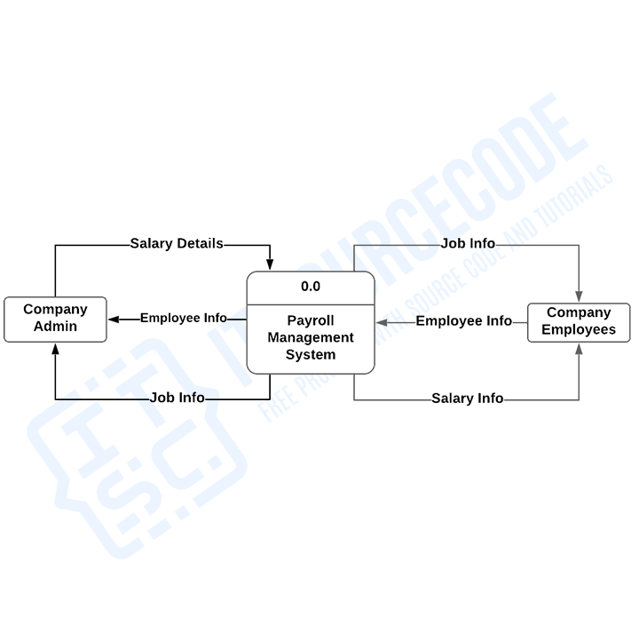Payroll Management System Project DFD Level 0 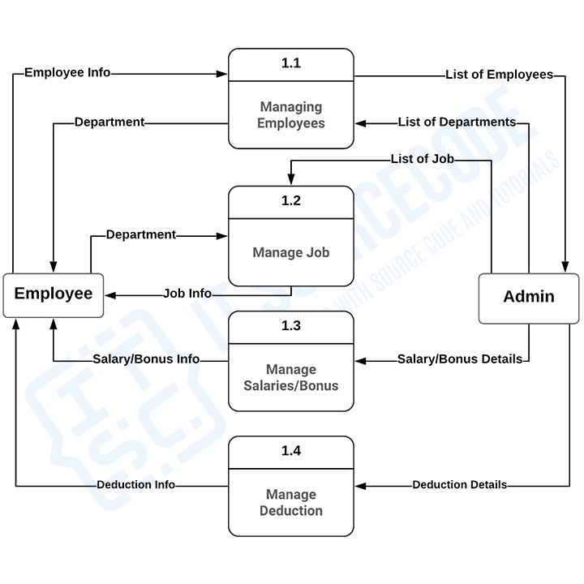Payroll Management System Project DFD Level 1 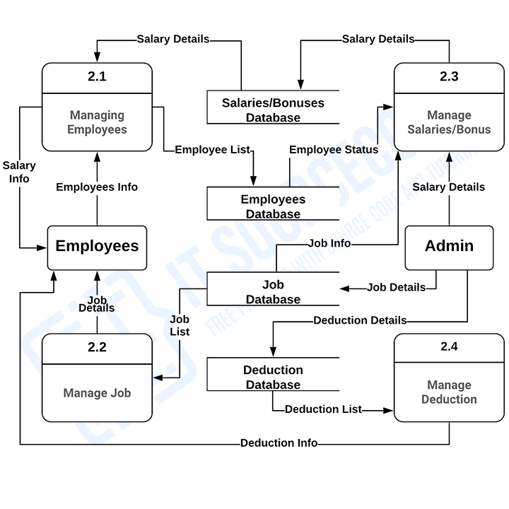Payroll Management System Project DFD Level 2

Payroll Management System ER Diagram - also known as Payroll Management system Project database design. This Payroll management system database design was made based on managing payroll requirements. The system can encode employees’ information. Payroll admin can have access to the employees’ status and information in terms of working performances and salaries. They can handle the data needed in managing payrolls as well as the ranges of labors made by the employees.

The features included in the system ER diagram were the security and monitoring of the employees’ work and leave records, job information and status. These features were also listed and recorded in reports that served as the history of transactions done in the system.
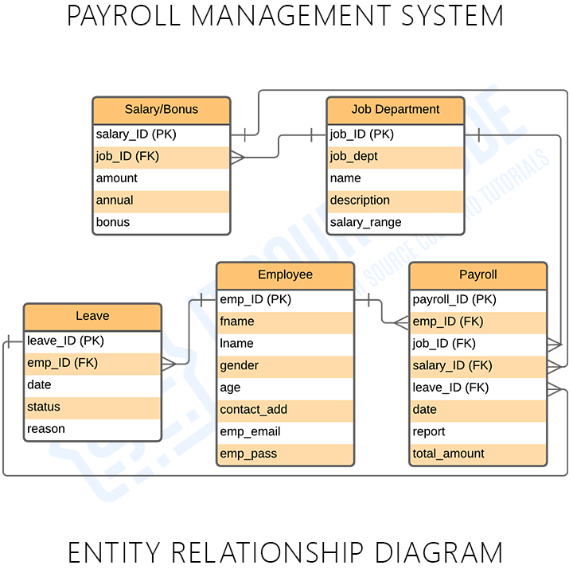Payroll Management System Project Database Design
Payroll Management System Use Case Diagram - discusses the meaning of the Payroll Management System project UML as well as its use case diagram using include and extend. The payroll management system use case diagram is a visual representation of how a user might interact with a program. A use case diagram depicts the system’s numerous use cases and different sorts of users. The circles or ellipses are used to depict the use cases.

Payroll Management System General Use Case - shows the general processes or function that the system could do that is based on the transactions done by the admin or employer in managing the salary of their employees.
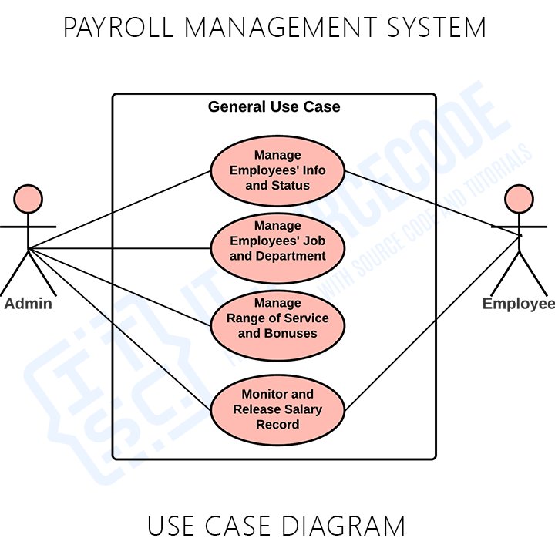

Monitor and Manage Employees’ Information and Status - This is where the admin or the employer/user of the system could manage and monitor their employee’s information and status. In this process they were able to assign the field of work of their employee as well monitor their outputs and range of service.
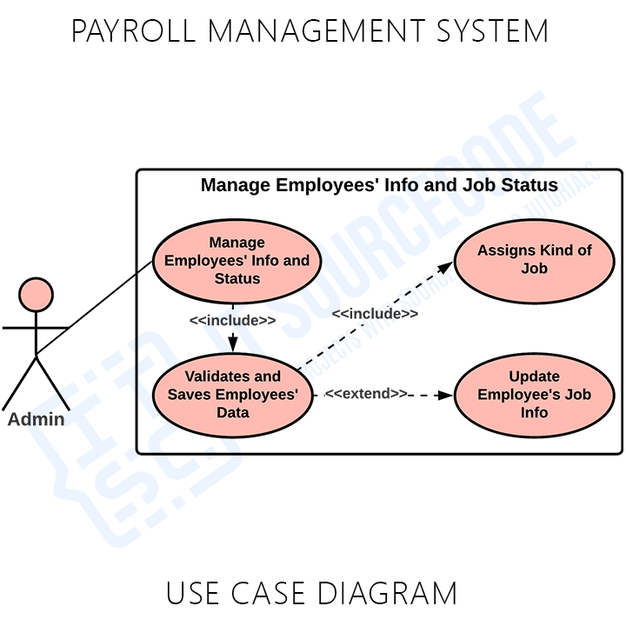Monitor and Manage Employees’ Information and Status Use Case Diagram

Monitor and Release Salary Record - Its process includes the assigning of job department to the employee, monitoring what type of word they would be and their salary rate. It is important that the employee should know his/her function as part of the company or establishment.
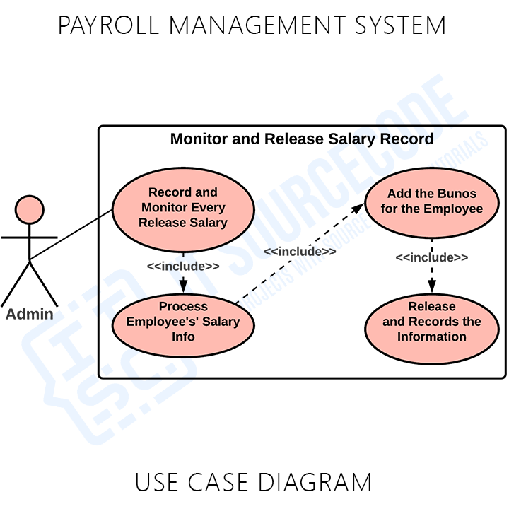Monitor and Release Salary Record Use Case Diagram

Manage Range of Service and Bonuses -This is the process where the admin will have to manage the bonuses that they give to their employees that is based on performance of the employees and their information. The system will ease this process because this will save the important information as well as calculate the fair salary for the employee.
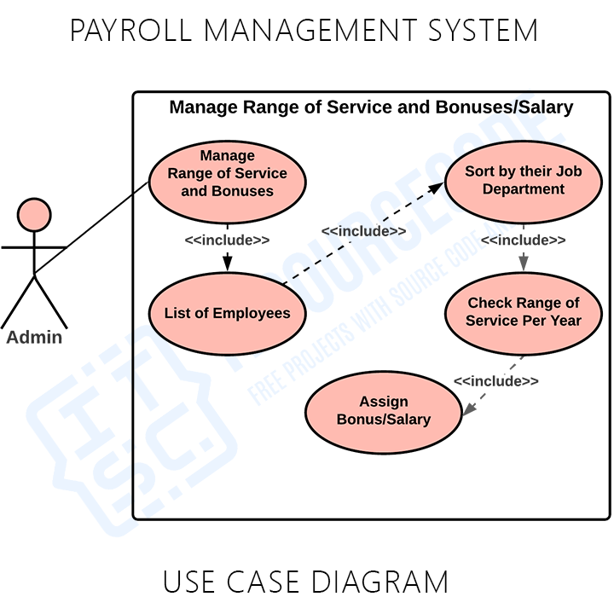Manage Range of Service and Bonuses Use Case Diagram

Payroll Management System Class Diagram - To create the Diagram for Employee Payroll Management System, you will first determine the classes. So, the classes that must be made in a Payroll are the salary, users, employees, taxes, bonuses and transaction. The mentioned classes were just general. If you want more complex or wider scope of your Payroll management system, then you can add your desired classes. You must also include the database on your Class Diagram for your system.
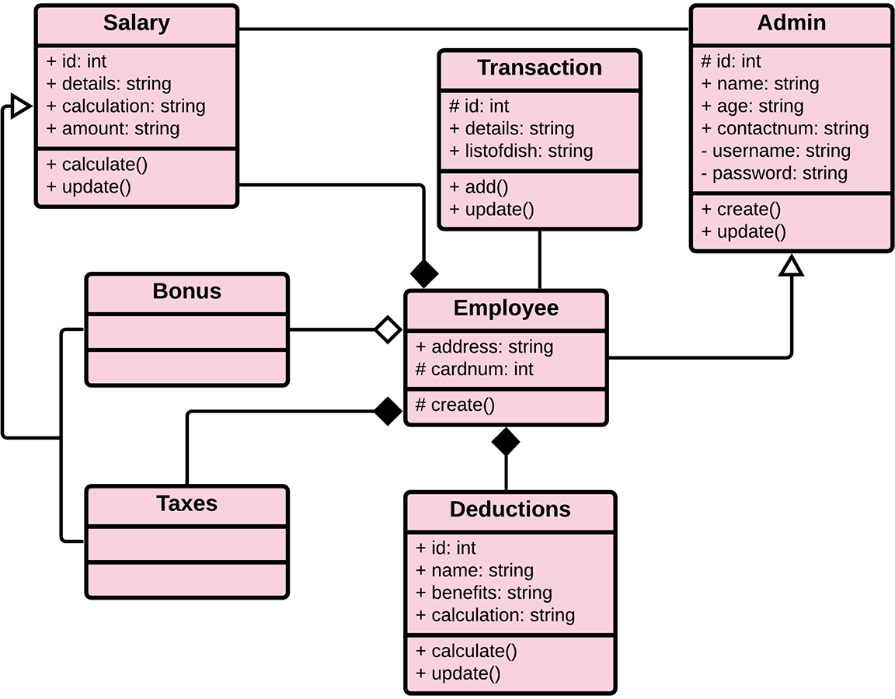Payroll Management System Class Diagram

Payroll Management System Sequence Diagram - The Payroll Management System is a sort of interaction sequence diagram that shows how a group of items interacts and in what order. Software engineers and business experts use these diagrams to understand the requirements for a new system or to describe an existing process.
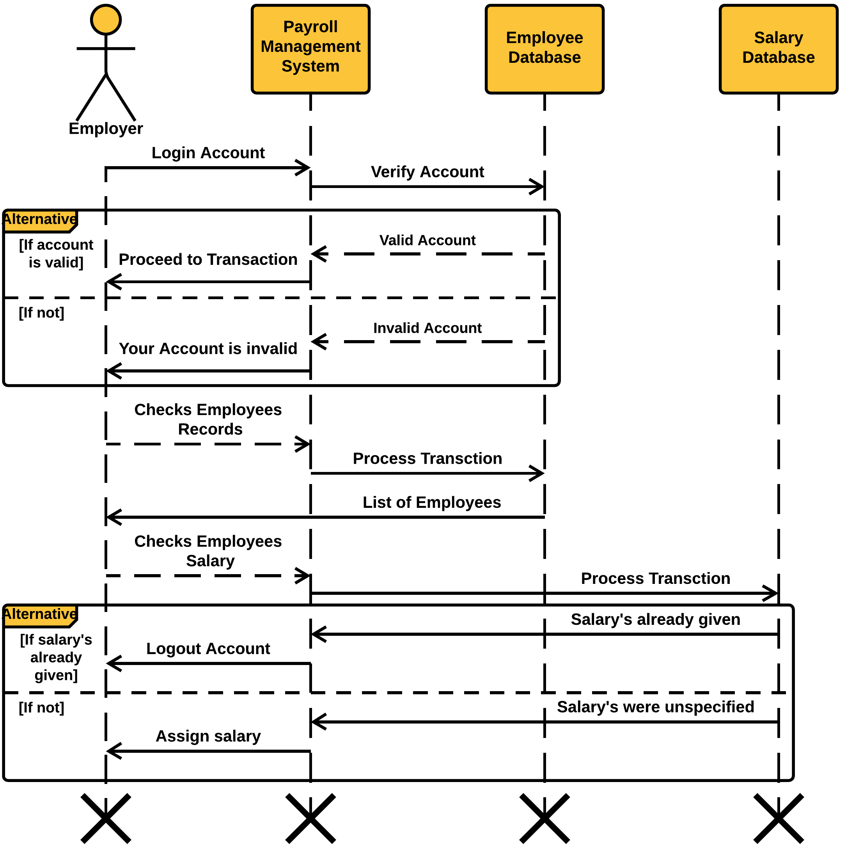Payroll Management System Sequence Diagram

