Library Borrowing System Documentation

Chapter I – Introduction

Project Context
Nowadays, in our society, computer technology is the most important advancement as people move along in this computerized world. These changes have big effects on man’s life; by making it easier and more convenient. Librarians have the responsibility not only to know how to manage a computerized library system but also to be aware that these changes will have a big help to them.

It helps a lot by providing sustainable technology towards quality education through consignment and effective learning. Computer technology is now in demand in our society. It is very essential in our daily lives. It continues to evolve and grow fast.

A library system is software that had been developed to handle basic housekeeping functions of a library. It helps to grant information on any book present in the library to the user as well as the staff members. It keeps a track of book issued, returned and added to the library.

Traditionally, library systems are used manually. Forms are given to the Librarian and they fill them of using pens. The manual library system is very time consuming and a tiresome task. The primary complaint of some Librarians with this manual system is the tiresome task of searching records. The fast changed of technology ascribe a lot to the development of the library system. The computerized library system may help the academe.

Purpose and Description
The software that had been produced is a library borrowing system, in this system, there can be 2 possible users; they are the administrators and the librarian. The administrators have the capability to open all sectors of the program and edit librarian’s information while the librarian is limited to adding book and student records but is not allowed to update or delete any recorded detail and transactions that had been recorded in the system. The purpose of the library borrowing system is to provide quality services. It aims to provide a good library borrowing system. The system provides a feature that can easily manage student’s information, book details and manage borrowing transactions.

General Objectives
The principal objective of the system was to computerize the manual system in maintaining the records of the book issue, book return of the student, stock sustenance and book research, so that the functioning of the library system will be easier and more convenient. Each student that is registered in the system is provided a registered library ID.

Specific Objectives
This objective overcame all the short comings of a manual system that was used daily. This includes the following:

- Developed a well-organized library borrowing system.
- Produced a well-designed and functioning system in accordance to the needs and wants of the borrowers.
- Minimized the task and the effort being performed by both the librarian and borrowers.
- Provided the school and the students a well-organize and well-presented reports.
Scope and Limitation of the Study
This study was limited to the Library St. Columban’s Academy that covers over 500 students, which the number greatly increases every year. In preparation, this system became more reliable and consistently providing enough support to the school’s library to accommodate an increasing number of students enrolled in every year.
The proposed system was made based on the wants and needs of the school, the system consists of registering books with specific book identification number, so that the librarian has an easy access in each book, search tabs for reliable, easy and faster monitoring of books and more importantly a report and evaluation papers can be generated in a well-organized and well-presented reports. Each student is limited to borrow one book every transaction to provide each student an equal chance of borrowing specific books.
This project system was highly recommended due to the rapid increase of computer related tools in the industry. With this proposed system features and functions of the school’s library will be able to accommodate more reliably consistent and faster in providing a better service to the student and staff.

Significance of the study
This study and its results are significant to the following:
Administrators - The system will lighten the paper works of the school as requirement reports.
Librarian - The Librarian can monitor well the students who borrow books in the library through reliable and correct reports.
Students - The students can easily borrow book without spending so much time.
Teachers - The students can be provided quick access for the library items so the teachers won’t worry enough if the students can manage to make a library research task given by them.
Future Researchers - The future researchers can use the study as their guide of reference for their future researches also that is related to database management system.

Definition of Terms
For clarity and understanding, the keywords that were used in this study were defined as follows:

Architectural Diagram - Process that show the flow event during the transaction in library borrowing system.
Feasibility - is the study of the relation of different aspects in creating the system. (https://en.wikipedia.org)
Hardware – Computer equipment used to perform the transactions in the library borrowing system. (https://en.wikipedia.org)
Library – is a room or building where a collection of books is kept for people to use or borrow. (https://en.wikipedia.org)
Library System – is a system that accepts data information as input and processes them to produce an output. (https://en.wikipedia.org)
MySQL – is an open-source comparative database management system. It is based on the structure query language (SQL) which is used for adding, removing and altering information in the database. (https://en.wikipedia.org)
Report – an official document that gives information about a particular object. (https://en.wikipedia.org)
Software – the programs that run on a computer and that performs the transaction in a library borrowing system. (https://en.wikipedia.org)

St. Columban’s Academy – Operationally, catholic educational institution that was established in 1950 by Rev Fr. Patrick Hurley. It is the educational institution to which our proposed system will be implemented.

Chapter II – Review of Related Literature

Background of the Study
St. Columban’s Academy (SCA) was among the first parochial school in the Southern part province of Negros Occidental. The establishment of the school almost marked the coming of the Irish priest of the Columban Missionaries. The first Columban priest arrives here in Cauayan in the year 1950 in the person of Rev Fr. Patrick Hurley to take over the retiring priest Rev Fr. Antonio Mamigo which is one of the rare local priests during that time. Fr. Hurley was successively followed by Rev Frs. Augustine Rowe, John Hynes, Colum O’ Halpin and Colum Rafferty. The priests were all products of the unique Catholic Irish education greatly from the religious forms. Now named as the St.Columban’s Academy which became the brand new, government recognized parish.

SCA’s administration deals most of the school transactions and records manually during enrolments, recording of student forms, payments and etc., which causes a time-consuming process. In the library, students are also manually filling up a sheet of paper for their information when they want to borrow books. Students are not instructed and guided properly during rush hours in the library which causes a lot of misleading and error transaction, records and a not well-balanced distribution of book for students every day.

By developing a computerized library borrowing system for St. Columban’s Academy this will provide an easy way of encoding, recording and searching of past transactions in the library. This will benefit the students, they will have a high chance of borrowing limited number of books that are available in the library and keep in track of their transaction records, also the school librarian will greatly benefit with the system because it will be easier for the librarian to manipulate the past and current transactions and to search and track the records of book and students in each transaction.

Related Systems
Within this chapter the researches presented the reviews of literature and systems that are greatly related to our proposed system, with this we will understand the past studies for us to develop a lot more effective and efficient system for the school.

Electronic library management Systems
In accordance to the study of Robertson (2004), Library management system (LMS) known as an automated Library System is software that is developed to deal with the basic functions of a Library, and provides a complete solution for the administration of a library’s technical, economic and social functions and services to the users. These functions range from; tracking the assets held by the library, managing book and user records, through to supporting the daily work over. These systems are used in almost all libraries large and a small once.

Digital Library Services Systems
According to the study of Stephen, Maeve & Philips (2007), in a traditional sense, a Library is a large collection of books such as research proposals, dictionaries, encyclopedia, and many more; it also can refer to the place in which the collection is housed. Today, this kind of terms can refer to any of the selection, including digital sources, resources, and aids. The collections can be of print, audio, and visual materials in various layouts, containing maps, prints, and documents, microform, compact disk, cassettes, videotapes, digital video disk, e-books, audio books and many other electronic assets. The places where this material is stored can range from community libraries, consent libraries, intimate libraries, and can also be in digital arrangement, stocked on computers or approachable over the internet. The term has acquired a subordinate meaning: “a group of beneficial tangibles for common use.” This sense is used in fields such as mathematics, computer science, statistics, analysis and electronics. They cast that, a library is systematized for use and cared by a public body, an institution, association, or an intimate individual. Public and institutional collections and services may be designed for use by people who choose not to or cannot sustain to obtain an extensive collection themselves, who need material.

Library reservation system
Library is a substantial part of the academic sector as well as some professional sectors too like, Advocacy etc. The effectiveness of a library relies on how the book and other materials are organized and how easily one can get the books that they preferred. Mainly, what we see nowadays is manual library management system whose method of operation is very much unsettled. What we are doing is that we are proposing a computerized library management system, which provides better and efficient service to the library members. This software is meant to transform the unsettled manual system to a more adequate computerize system. This application can be used conveniently in educational institute and certain professional districts also. This application presumes that the user doesn’t possess the right to alter information about books. In accordance to Yao ‘s (2013), background of the study.

LAN (Local Area Network) Based Library System
As its names convey; the system is affiliated to a LAN or also known as Local Area Network. This kind of system provides users exceptional service with regards to the system’s activity. The transactions that will take place in the LAN-Based Library System are branched into two types: the server-based and client based. Server-based transactions are the transactions which can only supervise and oversee by the librarian due to some factors such as security. These transactions are being done in the server only, as its name convey. Customer-based transactions are the transactions which can be done in the client computer in the library or through internet.

Chapter III – Methodology

Methodology
This chapter begins on the scrutiny about the project research design methodology together with the development of the system operation, process and testing. The second part discussed the architectural diagram interface of hardware and the last part showed the recommended hardware, software and network specification.
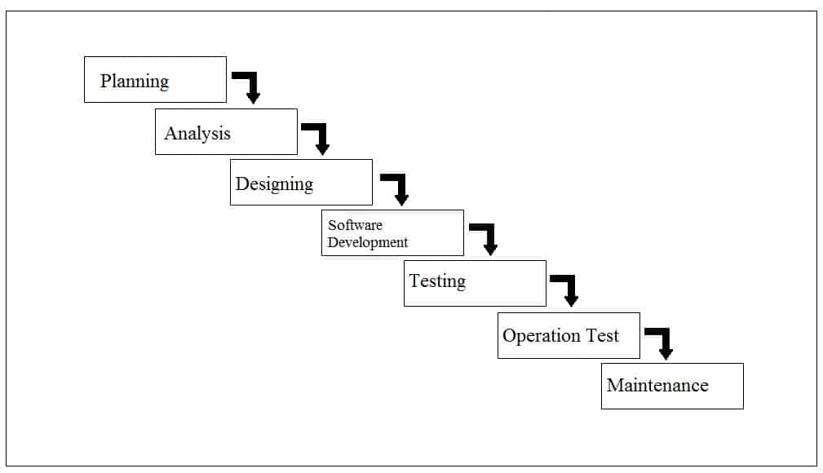
Figure 1: Waterfall Model Project Design Model

Throughout the project development after the researchers conducted interviews and research regarding the proposed system, the researchers have decided to use Waterfall Model for the System Development Life Cycle (SDLC), because this model gave the researchers lot of advantage including; in each stage and activity done in development of the project those stages and activities were easily explained which benefit both the researchers and the client and also in each verification and review of each stage can easily locate and repair errors that may occur in the program.

Planning
During planning phase of the system, the researchers conducted an interview to the client to gather some data about on how the librarian manage the books, borrowed book records, returned book records, all student’s records in the library. It is observed that the librarian manually writes all the transactions and maintenance records of every student who borrowed or returned the books in a piece of paper, so the researchers plan on developing the management by improving the managing of records by making it computerized to make it more effortless to both the librarian and clients of the library in the future. The researchers also plan to provide a more secure and a large amount of database storage for their records to be safe.

Analysis
The proposed computerized Library Borrowing System was designed purely from the users’ viewpoint without considering the restraint of hardware (such as computers hardware and software). In addition, system frameworks required to attain such designs was clarified. After checking requirement specifications included in the basic plan, the overview of the project was represented through the use of diagrams (Figures: 3-5) so that the alternation and flows of data can be easily assumed.

Designing
The software design particularly designed to the librarian of the school; the researchers used a user-friendly design to attract the user to use the new library borrowing system. Here, the system was arranged and constructed purely from the users’ aspect without considering the constraints of hardware (such as computers). In inclusion, system structures enforced to achieve such designs were clarified. After checking the requirement stipulation included in the planning, the synopsis of the system represented by the use of diagrams so that the processed of data can be easily presumed. Based on the likeness and the division into sub-systems and input/output plotting was performed. The entire project was branched into a number of modules on a utilitarian basis, and each module was further divided into smaller entity. In designing of the code, such as the boldness of coding system, was conducted. In addition, relationships between the data were analyzed.

Software Development
Coding
In the development of the system, the researchers made use of Microsoft Visual Basic Studio 2008 for encoding the source code of the system, the researchers also made a module for loading of data in each specified field in the system, in order to be accurate and fast acquisition of data and information.
Testing
After finishing the main parts of transaction being done in the system the researchers tested it and there was a lot of learning that the researchers encountered, it made the researchers realized minor and major mistakes in the system and it gave more understanding on how to develop it, after several weeks, the system has been successfully introduced.
Operation
In the operation test, the researchers conducted a test of our system with our fellow BSIT-III students in order to verify and secure the system will satisfy the clients. The researchers received comments and suggestions for consideration.

Maintenance
Maintenance will be conducted once the system is deployed to our clients, to maintain good performance all throughout the school year, maintenance will be done if the clients make a request. The researchers will also conduct a yearly maintenance to ensure their satisfaction.
Constraints
The following were the constraints the researchers had encountered during the gathering of information and making of the system:
- Insufficient Funds – Not enough fund to buy the proposed product for their school’s library system. This problem is commonly caused by lack of financial preparation for the upgrade of their school’s library system.
- Operating Systems – Variation in operating system affects the effectiveness of our system. If the school’s operating system is not compatible the proposed program will not operate or function well.

Architectural Diagram Interface of Hardware
The diagram shows the management server. This is where all the process starts. It shows that it delivers and retrieves data from the storage servers and is distributed to the librarian workstations. Management server is also responsible for passing up the database to back-up storage to secure a copy of all registered book and students in the system including their borrowing and return book transactions.

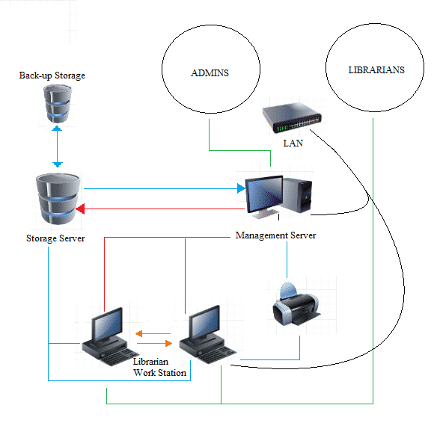
Figure 2: Proposed SCA Library Borrowing System Architectural Diagram

System Testing and Implementation
In order to make this project successful, the researchers let the proponents test and evaluate SCA Library Management System in order to receive feedbacks and to produce a reliable and effective system.
SCA Library Borrowing System was tested in the school laboratory by the proponents. Firstly, the selected student will login as an administrator to see and evaluate the functions of administrator in the system. Secondly, the researchers let the two students to login as Librarian to evaluate the functions made for the librarian’s point of view in the system.
SCA Library Borrowing System is a customized system which is designed from the client’s desire in the system to make it more user friendly to the target users. The items below are the features included in the system.

SCA Library Borrowing System Features
This SCA Library Borrowing System will feature the following:
- Computerized Admin / Librarian / Student Account Managements
- Secure storage for accounts and transactions
- Easy book borrowing schemes
- Generating well-organized reports

Recommended Hardware Specification (Server / Work Stations)
For SCA’s Library Management System be deployed and run in a perfect function the clients must first implement the following hardware specifications.
- Intel Core i3-2100 3.10GHz
- 8GB 1333MHz DDr3
- Printer
- Optical Mouse
- Keyboard
- Monitor

Recommended Software Specification (Server / Work Stations)
- Windows 7 Ultimate / Professional
- Visual Basic 2008
- PHP, MySQL
- MySQL Database and MySQL utilities
- Crystal Report

Recommended Network Specification
- Dual 1 GB LAN ports
- UTP cables
- RJ45

Chapter IV – Existing System

General Objective
This library borrowing system is created in order to have a good control and a well-organized borrowing of books for the students of St. Columban’s Academy.
Specific Objective
To accomplish this objective this will include the following actions such as;
- Recording borrowing transactions.
- Provide quality and time sufficient service to the students.
- Provide reliable and easy to manage records of past transactions.
Scope of the current system
This system is only limited to the students of St. Columban’s Academy in which the needs of borrowing books in the library increase yearly. As the number of students grow the number of demands in borrowing of books in the library is also growing.
This system is performed manually the recording of books being borrowed, returned, damaged etc.., that is ideal only for a small demand of students. Due to the lack of money and technological devices, this current system is the best and most ideal thing to be done to provide track records in each transaction.

Concept of Operation
The first step in the current system`s concept of operation is the student will search for the book he needed in the library. After finding the specific book, student will go to the librarian. The librarian will then ask if the student will borrow the book overnight. If the student will just read the book the librarian will just get the library card of the student and record the time, the title of the book, number of the book, and the author of the book. If the student will bring the book outside the library, the librarian will then check the status of the book if it is good to be released. If the book is in good condition, the librarian will get the library card of the student and record the time borrowed, expected date to be returned, the title, author, and number of the book. In returning the book, the librarian will check the book if there is any damage. If the book has damaged, and returned over the due date, penalties will be charged.
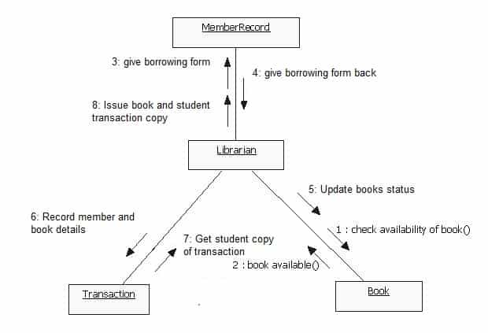Figure 3: Existing System Activity Diagram

Data flow Diagram of an Existing System
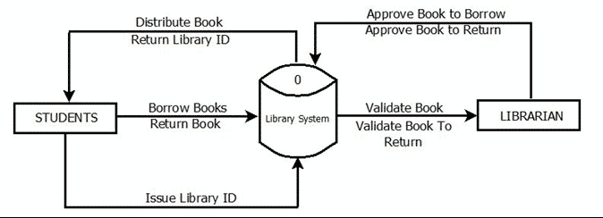Figure 4: Existing SCA’s Library Borrowing System Data Flow Diagram
The current library system starts with the student. The student will borrow books to the librarian, and then the librarian will validate the book to see the condition of the book before the student borrows it. Upon the approval of the librarian, the student will surrender his/her library ID. Then the librarian will give the specific book. Upon returning the book, the librarian will check its condition and give approval to the student. There the librarian will return the student’s library ID.

Chapter V – Proposed System

Proposed Solution
Throughout the research, the researchers came up and decided to propose a quick and easy transaction for all the manual difficulties in managing the Library have been rectified by implementing computerization to make it faster and reliable managing system, the researchers will also provide a user-friendly interface for the librarian and administrator and also a fast accessible database with a secure and huge amount of storage capacity. It will also provide a fast phased of technology attributed a lot to the improvement of the library system.

Scope of the Study
The proposed system is made based on the wants and needs of the school, the system consist of registering books with specific book identification number, so that the librarian will have an easy access in each book, search tabs for reliable, easy and faster monitoring of books and more importantly a reports and evaluation papers can be generated in a well-organized and well-presented reports.
In this project the system is highly recommended due to the rapid increase of computer related tools in the industry. With this proposed system features and functions the school library will be able to accommodate more reliably consistent and faster to provide a better service to the students.
The SCA’s library borrowing system starts with the registered administrator’s account which was made by the system programmer and is given to the supposed administrators of the system when the system is activated, the administrator will add users to the system which is the librarian, when librarian is registered he/she can now manage and record books in the system. He/she can register students who enrolled in the school. If a student, who is registered in the system, wants to borrow a book, he can inquire with the librarian if the book is available or is already borrowed by another student. The moment that it is available he must search the book in the library shelf and present the book with his registered library ID, the librarian will encode the book and student ID number in the system and when it is encoded the system it will automatically record the book and student details in the database.

Concept of Operation
In the second main transaction, when the student will return the book, the librarian will search the borrowing transaction records, when the record is found, there will be three (3) outcomes. First, when book is returned in a good condition and is not late there will be no penalties to be released. Secondly, loss of book or damaged, the librarian will release a penalty report which will be forwarded to the accounting office through a printed-out report. Lastly, when the book is returned late, the librarian will sum-up the total number of days. There will be a fine of 20php per day and will also be forwarded to the accounting office in the same manner.
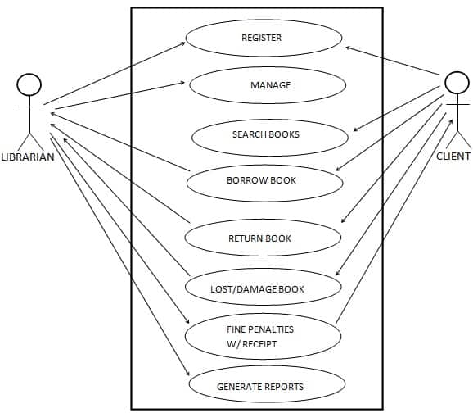
Figure 5: Proposed SCA Library Borrowing System Use Case Diagram
The main actors as shown in Figure 5, Proposed SCA Library Borrowing System Use Case Diagram are Client, Librarian. The corresponding use cases for the Client are, Inquiry for Membership, Search Book, Borrow Book, Book Return, Pay Fine and for the are Librarian, Search Book, Issue Membership Card, Issue Book, Return Book, Charge Fine In Case of Late Return, damage or the book is lost; maintain the Book Records, Add Books, Remove Books, Add Members, Remove Members, and Update Member. Also generating report for client and school needs.

Use Case Description
The table below describes the functions, conditions and alternative flows to be met of all the entities used in the use case diagram.
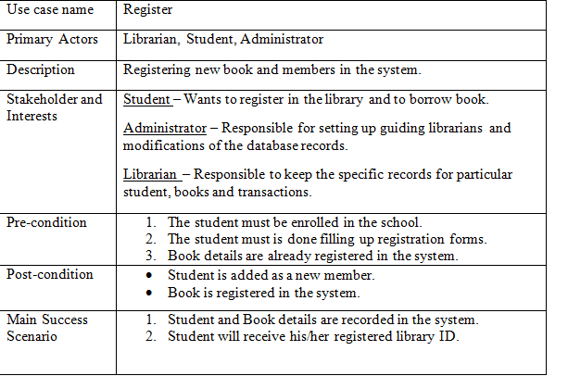
Table 1: Register
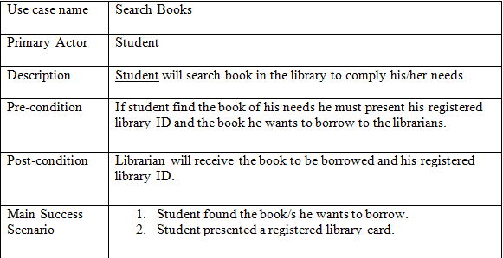
Table 2: Search Books
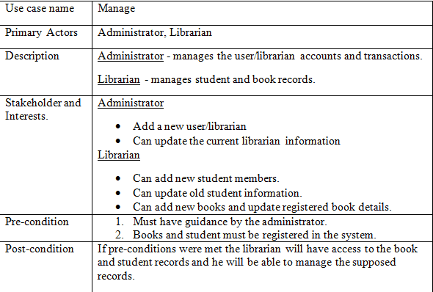Table 3: Manage
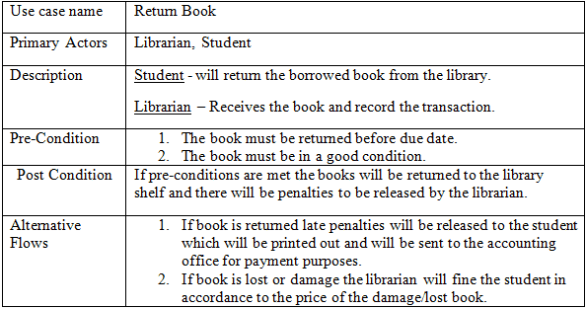Table 4: Book Return
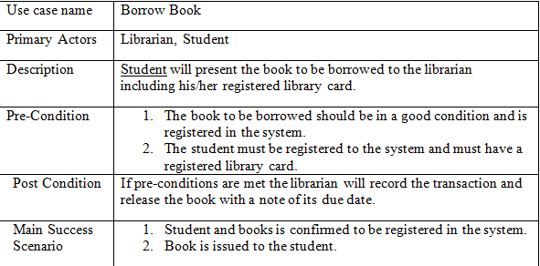Table 5: Borrow Book

Data Flow Diagram
In figure 6 of the proposed system’s Data Flow Diagram shows all the concept and flows of each entities and operation of the proposed system.
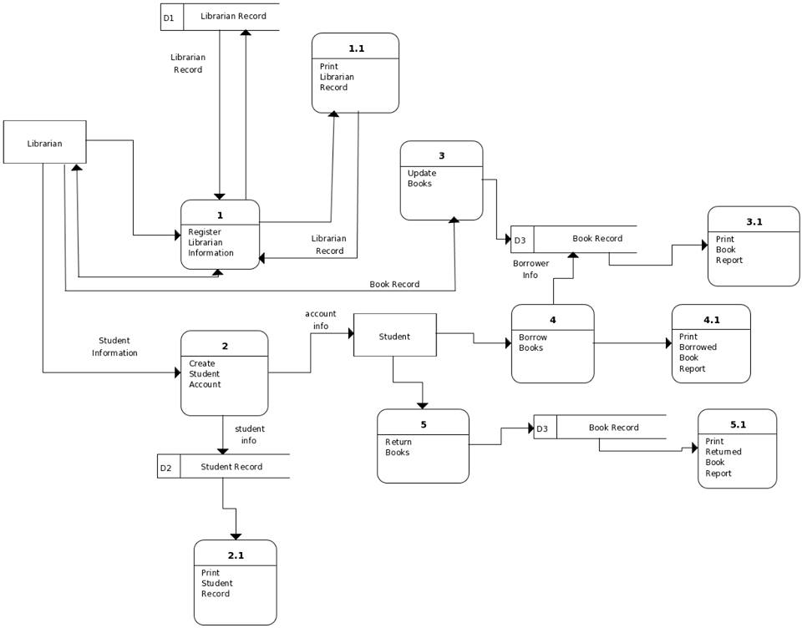Figure 6: Proposed SCA Library Borrowing System Data Flow Diagram
The librarian will log in to the system and then the librarian will register students and books that are in the library. If the students have been registered and wanted to borrow books, the student will search the book/s, and then he/she will present his/her registered library card together with the book/s he/she intended to borrow. The librarian will record the transaction using the proposed system and will set the due date for the book to be returned. After recording he/she will release the book/s and student’s library card together with the receipt. When the student returned the book before the due date, the staff will record the transaction successfully and update the book status. In case of loss or damaged, the librarian will give a fine to the student that will be given to the accounting office for penalty purposes.
Data Dictionaries
These tables below provide the entire database tables details such as Field Name, Descriptions, data types, character lengths.
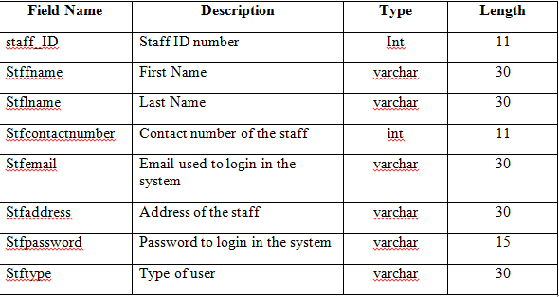Table 6: tblusers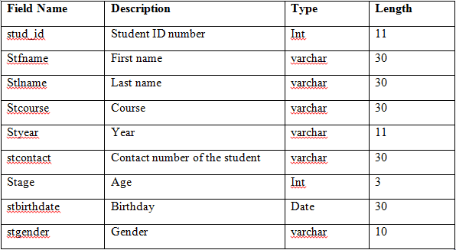Table 7: tblstudents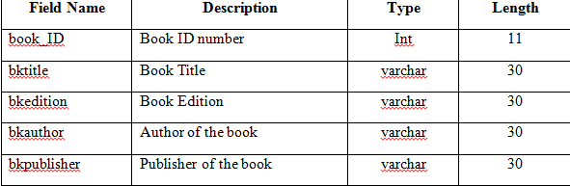Table 8: tblbook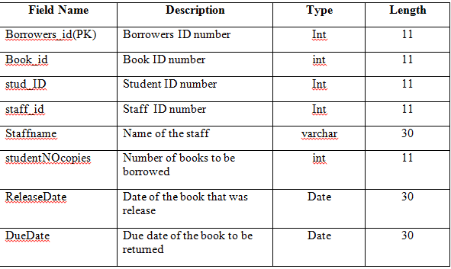Table 9: tblbtr
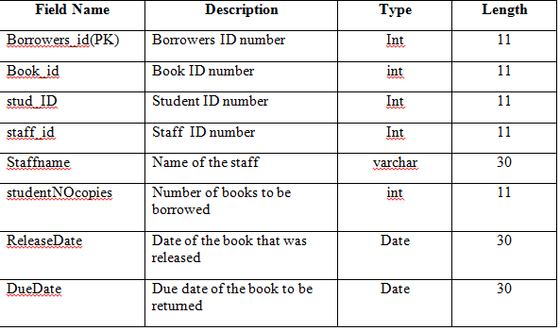Table 10: tblreturn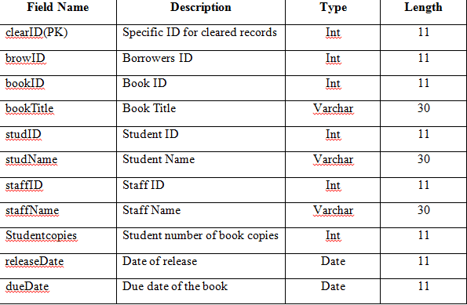Table 11: tblclearrecords
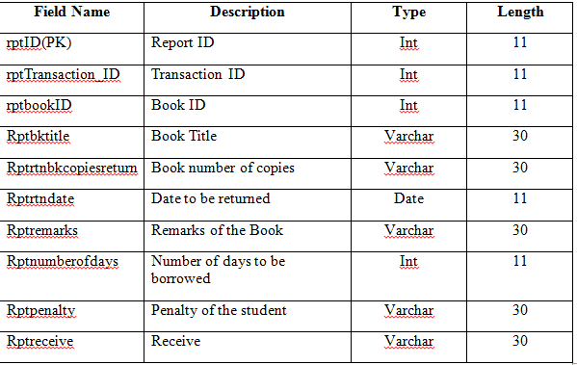Table 12: tblreports

Class Diagram
Figure 7 Proposed SCA Library Borrowing System Class Diagram shows the system entity, attribute and operations and each relationship among objects.
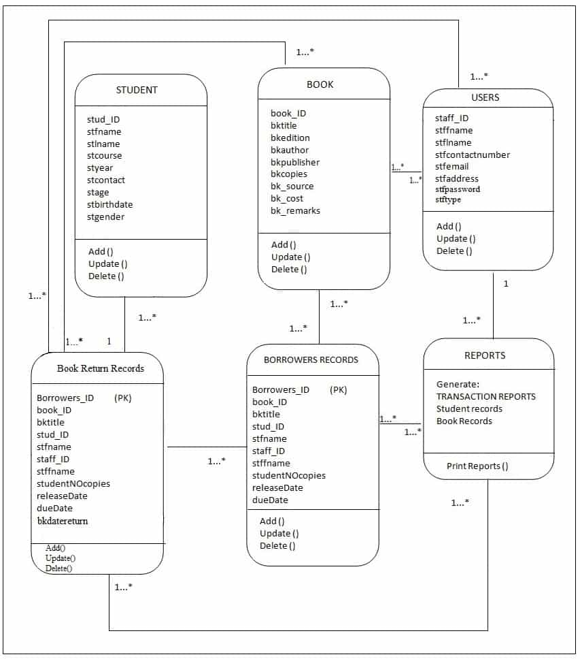Figure 7: Proposed SCA Library Borrowing System Documentation
Entity Relationship Diagram
Figure 8 Proposed SCA Library Borrowing System Entity Relationship Diagram shows the system entity relationships in each entity and their supposed functions in each relationship.
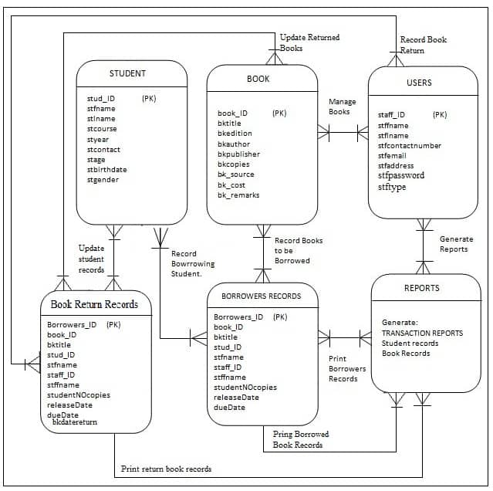Figure 8: Proposed Library System Documentation
Based on figure 8, the proposed system’s Entity Relationship Diagram are the entity of the proposed SCA library borrowing system database, which are presented by tables; the tables are made to meet the required specification of the system and provide a much more specific details of each entities within the system.

Advantages
The following are the advantages of our system:
- Provides quality and time sufficient services.
- User friendly and easy to use.
- Provides specific reports.
- Reliable and easy to manage records
Disadvantages
The following are the disadvantages of our system:
- One (1) book per transaction only.
- No password recovery

Technical Feasibility
During the study, the researchers concluded that this study is technically feasible because there will be no much trouble and difficulty in getting the required resources for the development and maintenance of the system. As well as all the resources for software and hardware development is already available.

Social and Operational Feasibility
The proposed library borrowing system study is socially and operationally feasible for the organization because the system is developed with the organization’s wants and needs in order to easily understand and manipulate the systems functions, so the researchers and developers made sure that the system will be user friendly and can be easily operated to meet its fully operational function to provide the organization a social and operational system.
Economic Feasibility
In the development of the proposed system the researchers concluded that this study is highly and economically feasible because the organization will not spend large amount of money in order for the system to be developed and be fully functional. The only consideration left to do is to make an environment that is capable to attain the maximum usability of the corresponding resources.

