Hotel Management System Project Documentation

Chapter 1 - Introduction

Project Context
Nowadays people live in a completely different life compared with years ago since the arrival of the technology. Technology is one of the main ways we change the world. Whenever, people meet up together for a several hours, they’re going to require food, and beverages. This (Online Hotel Management System Documentation Chapter 1) hotel caters for parties like Birthday, Wedding, Anniversaries, Christening and Christmas parties. “The ultimate promise of technology is to make of a world that we command by the push of a button.” (Volker Grassmuck).

The advancement of technology has revolutionized the way we do things. It has provided us with means to improves our lives and maximize our sources, time and effort. With the use of this technologies many transactions have become faster, more efficient, accurate and effectiveness to the management. Technology is important in today’s world because it serves a variety of function in many of the most important aspects in modern society like communication, education and business.

The current system used by Alton Hotel is a paper-based system in all information of transaction are recorded and stored in a logbook. Operation it takes time to look for what they need and it is not efficient because the owner spends a lot of time in finding the record of the old transaction. They’re going a lot of time in changing the records of transaction if the filled up with wrong information due to human error. According to the manager of the hotel, because they keep on doing their job manually, it resulted to a very messy office, lots of papers around the desks and information gathered, the proponents came up with an idea of proposing a system that is relevant to the needs of the hotel, highly efficient to meet their needs and most of all simple. They need to use our system to make easier with their business. The Alton’s Hotel is located at Barangay 9 near Zaycoland Resort in Kabankalan City, Negros Occidental handled all logistics associated with food in a bucket, beverages and live band entertainment. The ambience of the place can refresh all the stress of every customer. They can enjoy the fresh air and feel relax. It can accommodate customers from time to time especially nearly places from Kabankalan City.

The proposed Alton Management System with Online Accommodate aims to organize data that computerized the process of managing their transaction and recording inventory of their food and beverages.

General Objectives
The objective of the study is to develop on automated system and to replace the manual operation currently used by the Alton Hotel.

Specific Objectives
This study aims to attain the following:
- To provide fast, efficient and reliable system by the way of managing the records of all their transaction.
- To evaluate the acceptability of proposed system.

Purpose and Description
The purpose of the Online Alton Management System is to lessen paper works, reduce human errors and make sure that the customer satisfied the service rendered.

Online Alton’s Management System is a computer-based system that enhances the productivity of their reservation services in terms of accommodate and adds for other information. They accept any reservation services in Alton’s place only and they not catered outside for any services. The system is an internet based. The system is intended for Administrator, Organizer, and costumers. All users can view a list of menus through the website.

Scope and Limitation
The ONLINE ALTON MANAGEMENT SYSTEM includes: Billing, Inventory, Website, and Accommodate. This system will change the manual system of the business in order for the user to work easier and provide faster transaction for the customer. It can produce an accurate and reliable report which includes print-outs of receipt for customer’s payment and inventory of menu’s, beverages, etc.

The system will only be manipulated by the authorized person like the owner or the personnel. An authorized person has a registered account in the system for the History of the system. Our study does not offer payroll system for the employees. The system does not accept a credits card.

Significance of the study
The proposed system would improve the operational function of the hotel. This Online Hotel Management System Documentation Chapter 1 will be beneficial to the following:

- The Alton Hotel. The system will provide automatic transaction to the hotel. It has a database to retrieve all the information needed in the transaction.
- Owner. Easy them to monitor and controlling their business.
- Manager. For they could trace all transaction efficiently all reports are accurate and it provide more reliable recording of sales of the hotel with comparison to its actual cost. In addition, the data needed by the company to decide matters in relation to inventory can be easily generated.
- Cashier. The system will do the operation in locating the customer by their account number during payment process and will use printer that print-out official receipt.
- Customers. Help them reduce time and effort in queuing at the cashier counter, it also provides security to their payments and records.
- Researcher Future Researcher. The proposed system will benefit the future researchers by making this as their future reference in conducting similar studies.

Definition of Terms
These terminologies were gathered by the proponent for better and clearer understanding of the study.
- Billing. The process of making an official receipt.
In this study, it is defined as the process of sending an official receipt to the customer.
- Reservation. Provides food and Beverages normally at the social events.
In the study, it refers to the business of providing food services.
- Database. Allows data to be easily accessed, manipulated, updated and also used by an organization as a method of storing, managing and retrieving information.
In this study, all the transactions in the hotel can be stored at the database.
- Inventory. A complete listing of all menus and utensils in the hotel, made every day by business concern.
In this study, all the menus of the hotel can automatically monitor and to avoid over supplies.
- Accommodate. An arrangement made in advance to have a table available at a hotel. In this study, it refers to the advance booking of a table made by the customer.

Chapter 2 – Review of Related Literature

LOCAL RELATED LITERATURE

Barrio Fiesta Hotel
According to Ms. Evangelista Ongpauco, Manager Barrio Fiesta located at Sm North, Edsa with today’s fast-paced world, finding time to have dinner is almost impossible. Most of the time you’d rather catching on some sleep or you’re rushing finish last week’s workload before this week rools in Hotel like Barrio Fiesta have made possible for families to come together, sit down to a good meal of Filipino. Vouchers are valid for dine in only. Barrio Fiesta Hotel also offers accommodate. Cancellation of Accommodate redeem vouchers within validity period will render the voucher invalid. (Shira Ongpauco, 2012).

Sailes Diner Hotel
According to Ms. Joy Santos and Ms. Irene Lalu (manager) of sales Diner Hotel, this located at Susano Road, Deparo Caloocan City. In terms of their reservation transaction, the hotels receive orders from the customer over the counter. Customer will choose their order in a printed display menu above the counter. Customer will receive a printed receipt after the order was made the customer will receive easily identify where they will give the cooked dish or meal. The hotels accept accommodate for parties and other reservation events customer must give a down payment the hotel accept the accommodate for parties and other reservation events. (Joy Santos and Irene Lalu, 2014).

MJ Hotel
According to Mr. Michael A. Sarapi general manager of MJ Hotel located at Sta. Cruz Manila, California Village, Novaliches Quezon City. In terms of reservation transaction, the hotel receives orders over the counter. The customer will choose their order in printed menu and go to the counter. The customer will give their order and their payment. After order was made the customer will receive a number the number service as their identification so that the waiter can easily identify where they will give the cooked dish or meal. The only computerized system their hotel is the reservation event. The customer must give a down payment. The hotel accepts accommodate for parties and other reservation events. Customer must give a down payment so that the accommodate will be accepted. (Michael Sarapi, 2012).

FOREIGN RELATED LITERATURE
Flight Reservation
According to Othman and Liawati, Flight reservation uses an inventory control which has the data level where the day-to-day business is organized. Activities here are data-driven and primarily concerned with short-term planning and recording events. Inventory control is concerned with maintaining the correct level of stock and recording. (Abu Othman and Nor Liawati, 2013)

Baggers Hotel
According to Mr. Michael Mack owner of the Baggers Hotel they reinvented the hotel and overtaken the hotel of the first and second dimension (service and self- service hotel). Experience the state of art information technology in a hotel for the first time. Before placing the orders via touch screen, the customer can read about selected suppliers, the concept or attractive bonus system. Baggers hotel software offers hit list of other guests to ease their choice. And after dinner they can evaluate the meals, service or the ambience of the hotel, recommend us Via E-mail or SMS- The customer can do directly per touch screen at your seat. (Michael Mack, 2015).

Quick Staff
According to Studios, Quick staff is a system which can help to schedule and organize the staff for the events/job with ease and speed. Their system contains the schedule and assigned task of their employees. (Adoro Studios, 2014)

LOCAL RELATED SYSTEM
Hotel Reservation System
According to Attias, an application is a better way for the customer to order what they want to and also it is the administrator trick in marketing their business. In this system, you can find where you can track all phone calls, meetings, order and activities through online/internet transaction. The similarities of the proposed system to the Hotel Reservation System is they have a connectivity, web-based, accommodate or reservation, and the differences is they catered outside or other places but Alton can cater only at their hoteland they have an inventory of all the menu and utensils. (Michael Attias, 2017)

Max’s Hotel Online Reservation System
According to Maximo Gimenez owner of Max’s Hotel Online displays different list of food and beverages provided with descriptions and how the food is being processed that determine the quantity that the customer wants to order. If patrons missed some order, it can update automatically by clicking the update food tray button. There’s no need for patrons to count the bill for the payment because it will automatically count once the patron click the items they want.The similarities of the proposed system to the Max’s Hotel are almost the same in terms of Connectivity, Website, Inventory, Accommodate and Gallery. (Maximo Gimenez, 2012)

Chownow Hotel Reservation System
Chownow Hotel Reservation System, a web-based reservation system that offers user interface, is innovative and easy to navigate, so customers use the app again in again. With reservation platform large orders are made electronically so there’s no room for error. Plus, the owner can set the minimum amount of warning time for kitchen. It sends data or information through Emails and Facebook. Chownow Hotel is similar to the proposed system in their Connectivity, Web-based and Gallery. The differences between the two systems is the Inventory and Accommodate not applied to Chownow Hotel Reservation System. (Ezra Adier, 2014)

FOREIGN RELATED SYSTEM
VillaTronco Italian Hotel Online Accommodate and Reservation Website
According to Carmella Villatronco, VillaTronco Italian Hotel is the oldest hotel in South Carolina. It has been owned and created by three generations of the Tronco family. They first introduced pizza to Columbia and are known to serve pasta and other authentic Italian food. They have an online accommodate and online reservation system which it can help to lessen the time and automate their accommodate and order. (Carmella Villatronco, 2016)

eZeeeMenu of Digital Hotel Menu, eZeeeTechnosys
eZeeeMenu works on both Apple and Android devices and it optimizes itself according to the screen size without breaking the experience for the guest or the staff Restaurateurs can fully customize the menu, categorizing various menu groups and items so that customers do not have to scroll through list of items, making it easier for the customers to navigate and know exactly what they are looking for. Customers will love the one-touch browsing experience on the device of their choice or device of hotel’s preference. This precision will save time of the hotels valuable customers and greatly enhance their overall service. (Pvt. Ltd., 2014)

Eveve Hotel Website
According to Mark Reilly, Eveve Hotel System demand for tables exceeds availability, accommodate becomes necessary for discerning guests, who want to avoid wasting time for diners who are resource-rich and time poor. They also offer accommodates; their accommodate boosts the customer experience and maximize revenue for the hotel. (Mark Reilly, 2013)

Table 1. Features and Comparison of Foreign and Local System
RELATED PRIOR ARTS | FEATURES
 | Connectivity | Web-based | Inventory | Accommodate | Gallery
Hotel Reservation System | YES | YES | NO | YES | NO
Max’s Hotel Online Reservation System | YES | YES | YES | YES | YES
Chownow Hotel Reservation System | YES | YES | NO | NO | YES
VillaTronco Website | YES | YES | NO | YES | NO
eZeeeMenu of Digital Hotel | YES | YES | NO | NO | YES
Eveve Hotel Website | YES | YES | YES | YES | NO
Online Alton Management System | YES | YES | YES | YES | YES

Chapter 3 - Methodology

This chapter discusses the overall study design and data analysis for the proposed Online Alton Management System, for development and understanding covering whole activities of the project. This includes the system development life cycle, requirements, system design, implementation, integration and testing, system deployment, and maintenance.

The design and methodology probably needed in any application or system as it serves as a basis for the development of the project. It also serves as a guide in following the step-by-step procedure. This could also help the users understand about the proposed system.

SYSTEM DEVELOPMENT LIFE CYCLE (SDLC)
The system development life cycle, the purpose of this article is to develop an understanding of the system development lifecycle and its role in managing the development of digital library systems. It is very important in developing a project.

There is different model of this System Development Life cycle that helped the proponents; one of it is spiral model that helped the step-by-step procedure of this system.

MODIFIED WATERFALL APPLICATION DEVELOPMENT METHODOLOGY
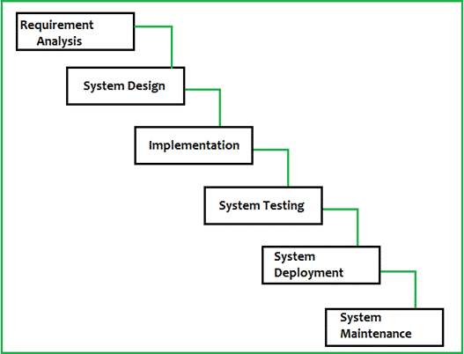
Figure 1: Modified Water fall Application Development Methodology
Figure 1: Shows of Water Fall Model is a breakdown of project activities into linear sequential phases, where each phase depends on the deliverables of the previous one and corresponds to a specialization of tasks. The approach is typical for certain areas of engineering design.

Requirements
The proponents conducted an interview and gathered information to the owner of Online Alton’s Services that is suitable of our system for the processed and to identify the constraints dependencies suggestion included of our proposed system.

System Design
In this phase, the proponents regulate additional analysis of the system to get a better appropriate design for the proposed system. The final system is constructed. Based on the developed of system design. The proponents also apply their plan on how handy their system will be used with different disposition and perception. The proponents defined the important features of the proposed system and cooperate the source coding that will be used in the system.

Implementation
In this phase, the proponents should estimate the system carefully to make sure that the proposed system will operate well. The proponents need to apprise, test and debug the system performance until project is fully operated.

Integration and Testing
In this phase, the proponents make sure that the users review and if there is any problem or bugs on the system the proponents will go back to analysis phase to fix the problem.

System Deployment
In this phase, the proponents make sure that the functional testing is done of our proposed system so that the client does not aspect some difficult during the installation of the software.

Maintenance
In this phase also includes control the remaining that may exist in the software even after the testing phase, and enhance the system to what client wants to improve in they also keep system alive.

Online Alton’s Management System Use Case Model
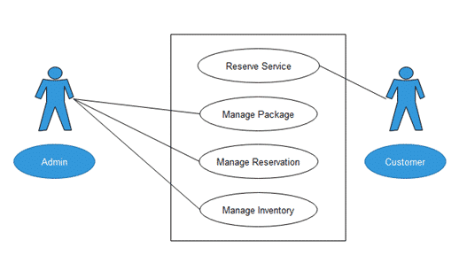
Figure 2: Online Alton’s Management System Use Case Diagram
Figure 2: Shows the Online Alton Management System use case diagram illustrates the interaction between the user and the system.

Reserve Service
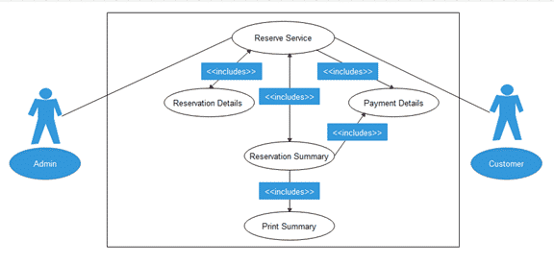
Figure 3: Online Alton’s Management System Use Case Diagram

Use Case Description
Figure 3: The table below describe the function, condition and alternative flows to be met of all the entities used in the use case diagram.

Table 2: Reserve service
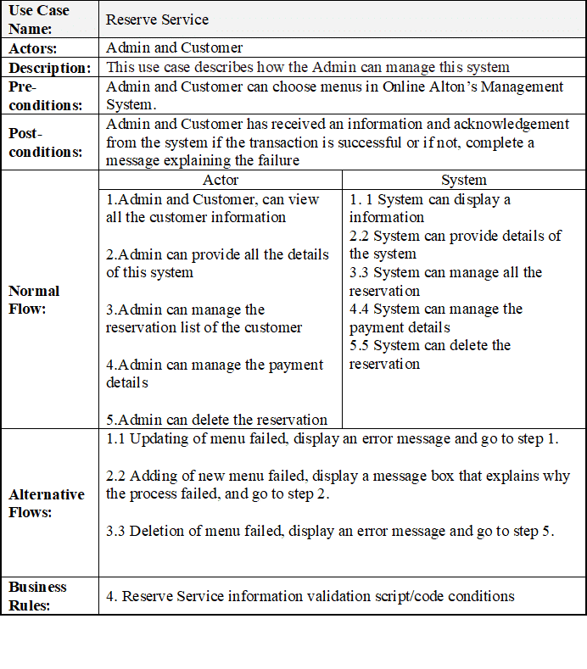

Manage Package
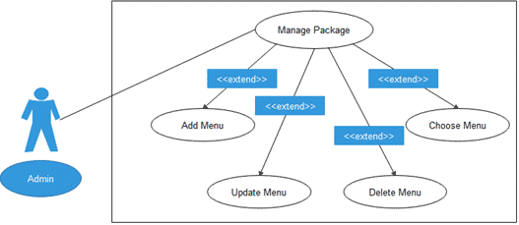
Figure 4: Online Alton’s Management System Use Case Diagram
Figure 4: Shows the Online Alton Management System use case diagram illustrates the flow on how the admin manage packages.

Table 3: Manage Package
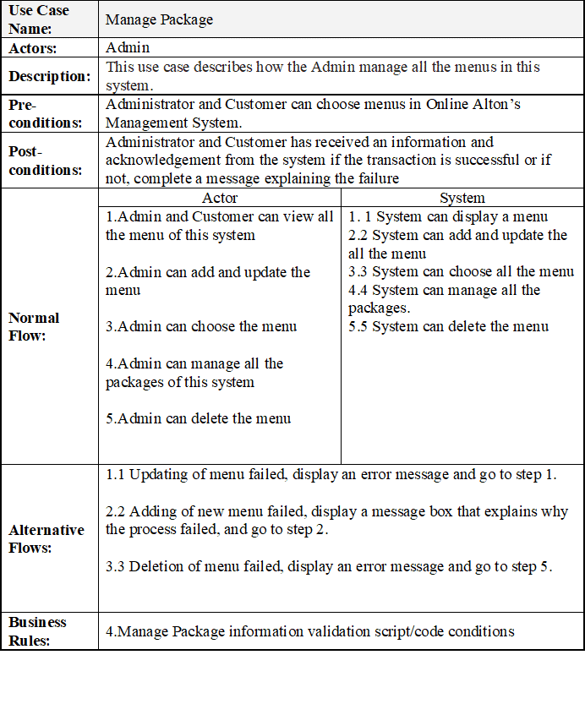
Manage Accommodate
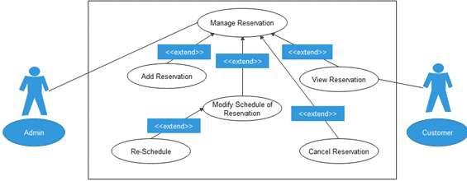
Figure 5: Online Alton’s Management System Use Case Diagram
Figure 5: Shows the Online Alton Management System use case diagram illustrates the interaction between the user and the admin.

Table 4: Manage Accommodate

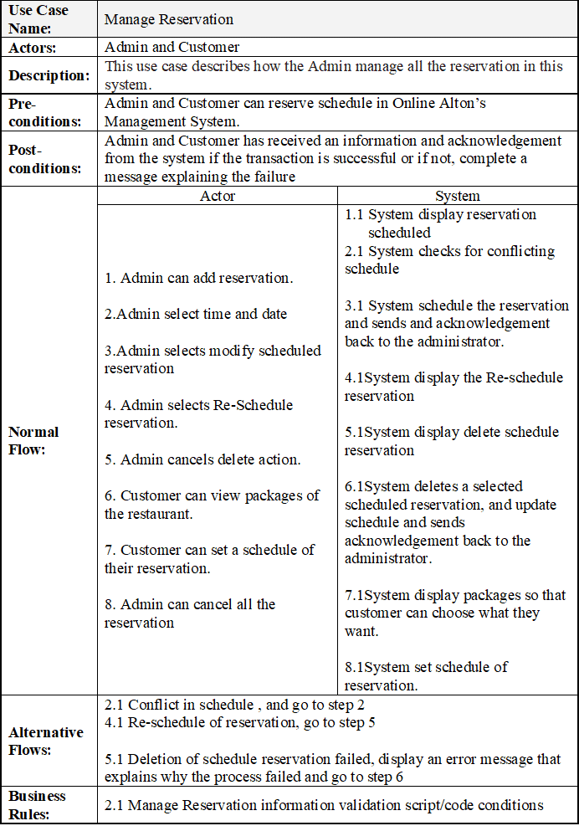

Manage Inventory
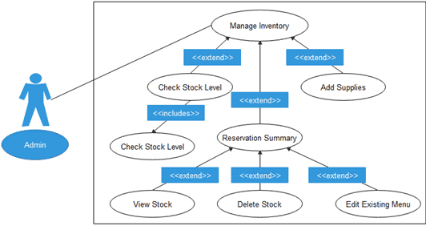
Figure 6: Online Alton’s Management System Use Case Diagram
Figure 6: Shows the Online Alton Management System use case diagram on how to manage the flow of inventory.

Table 5: Manage Inventory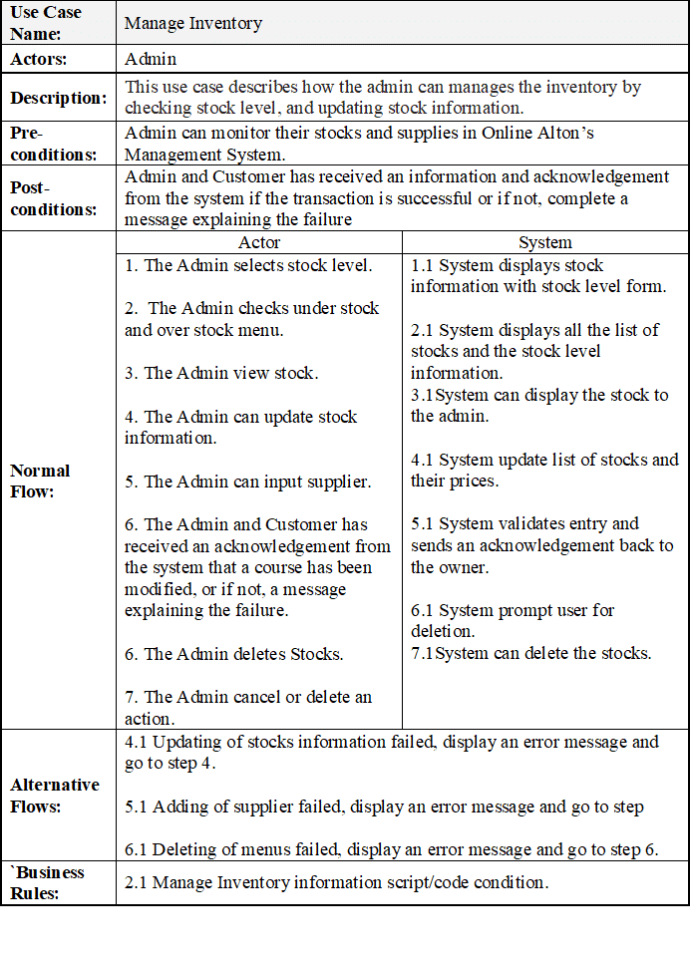

Activity Diagram
The illustration below shows the activity diagram of all the buttons in Online Alton’s Management System that shows the workflow of the events in the activity and it is used to detail every situation in the system during the execution of the said activities.

Activity Diagram for Menu and Accommodate (Client)
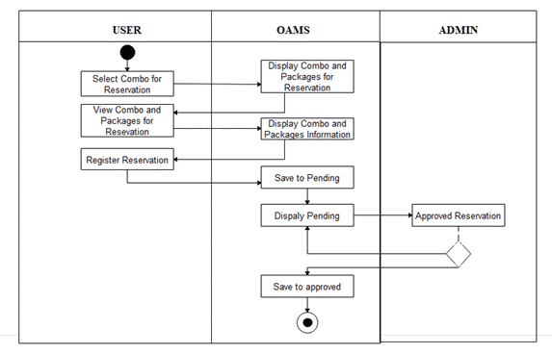
Figure 7: Online Alton’s Management System Activity Diagram
Shows the execution of activities when the user clicks the registration. The system will display the form.

The illustration below shows the activity diagram of all the buttons in Online Alton’s Management System that shows the workflow of the events in the activity and it is used to detail every situation in the system during the execution of the said activities.

Activity Diagram for Inventory of Items (Admin)
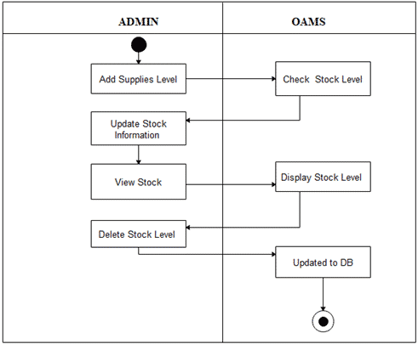
Figure 8: Online Alton’s Management System Activity Diagram
Shows the execution of activities when the user clicks the inventory button. The system will display the item information.

The illustration below shows the activity diagram of all the buttons in Online Alton’s Management System that shows the workflow of the events in the activity and it is used to detail every situation in the system during the execution of the said activities.

Activity Diagram for Manage Package (Admin)
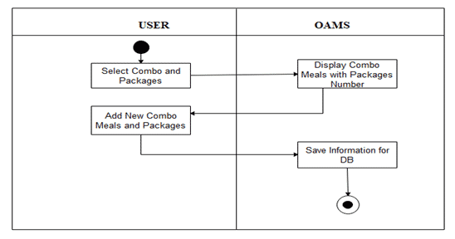
Figure 9: Online Alton’s Management System Activity Diagram
Shows the execution of activities when the user clicks the Manage Package. The system will display the item information.

Context Diagram
The Context Diagram of Online Alton’s Management System represented below shows the flow of the system throughout the system process. It shows what information could be input, where the data goes, and how it is stored.
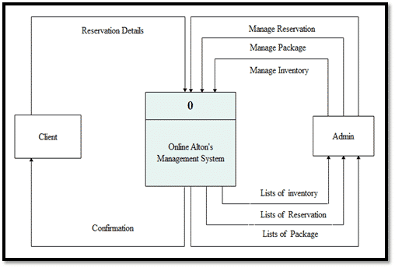
Figure 10: Online Alton’s Management System Context Diagram
Shows the sequence of the system, the decision and result made by the users.

Data Flow Diagram
The Data Flow Diagram below shows the data flow diagram of the proposed system. It shows all the process and function on how to operate the system.

Level 0 Data Flow Diagram
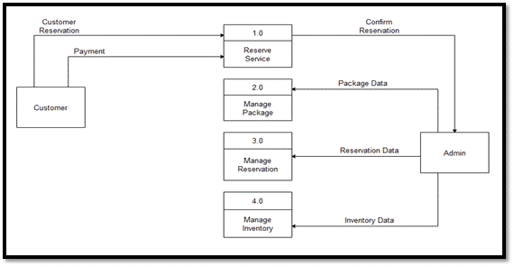
Figure 11: Online Alton’s Management System Data Flow Diagram
Data Flow Diagram of Alton’s Management System is represented above shows the flow of the system throughout the operating process.

Level 1 Reserve Service DFD
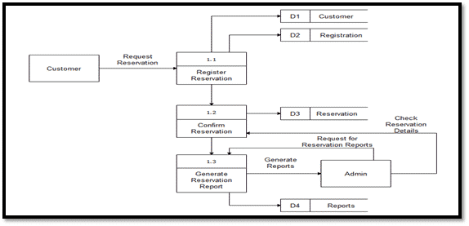
Figure 12: Online Alton’s Management System Data Flow Diagram
Data Flow Diagram of Alton’s Management System is represented above shows the flow of the Reserve Service.
Level 1 Manage Package DFD
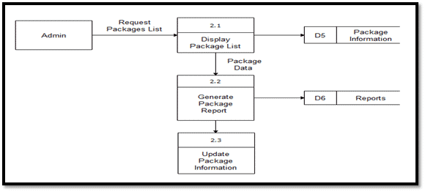
Figure 13: Online Alton’s Management System Data Flow Diagram
Data Flow Diagram of Alton’s Management System is represented above shows the flow of the system of the manage system.

Level 1 Manage Accommodate DFD
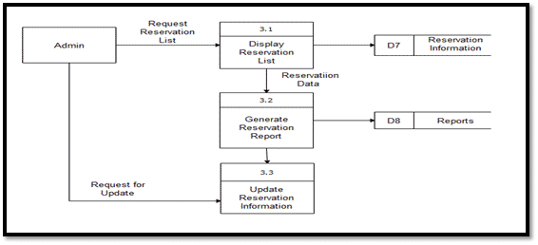
Figure 14: Online Alton’s Management System Data Flow Diagram
Data Flow Diagram of Alton’s Management System is represented above shows the flow of the system Manage Accommodate.

Level 1 Manage Inventory DFD
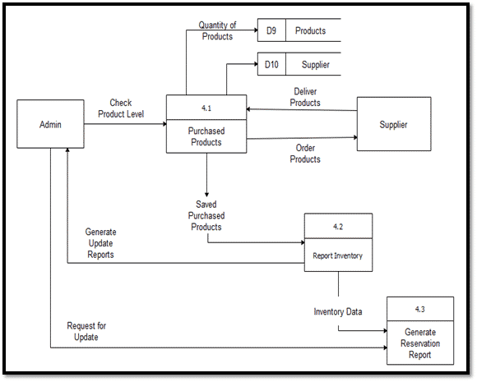
Figure 15: Online Alton’s Management System Data Flow Diagram
Data Flow Diagram of Alton’s Management System is represented above shows the flow of the system of Manage Inventory.

Entity Relationship Diagram
The Entity Relationship Diagram of Online Alton’s Management System shows the relationship of entity sets stored in a database. It indicates the logical structures of each database.
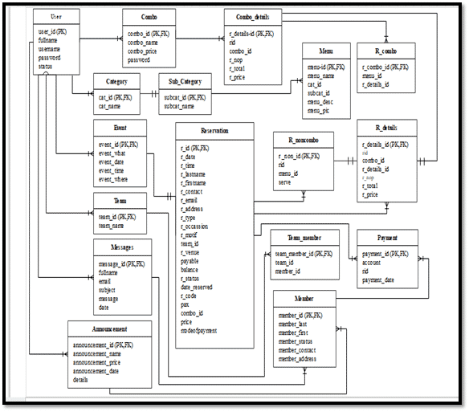
Figure 16: Online Alton’s Management System Entity Relationship Diagram
Shows the relationship of entity sets stored in a database of Online Alton’s Management System.

Data Dictionary

Table 6: List of Admin Accounts Table of Online Alton Management System
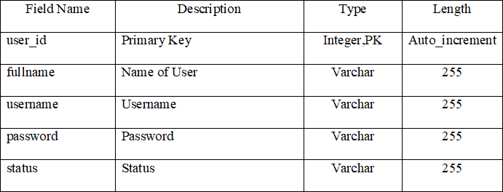

Table 7: Combo Table of Online Alton Management System
Table of the Combo
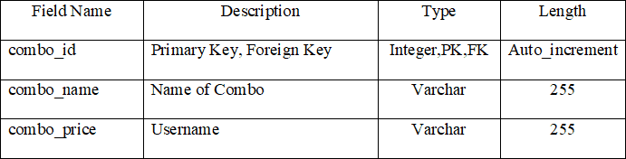

Table 8: Combo Details Table of Online Alton Management System
Table of the Combo
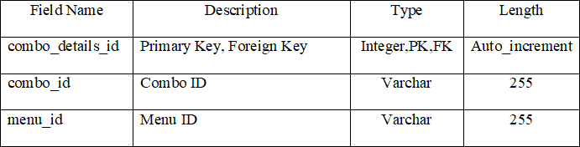

Table 9: Category Name Table of Online Alton Management System
Table of the Category
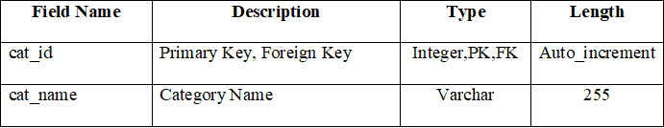

Table 10: Menu Table of Online Alton Management System
Table of the Menu
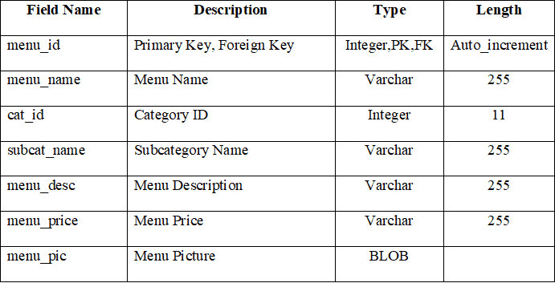

Table 11: r_Combo Table of Online Alton Management System
Table of the r_Combo
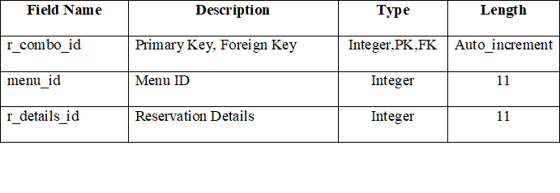

Table 12: Team Name Table of Online Alton Management System
Table of the Team
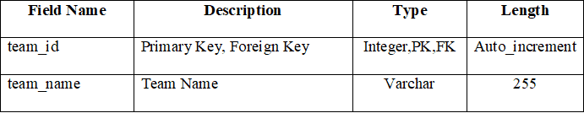

Table 13: Team Member Name Table of Online Alton Management System
Table of the Team Member
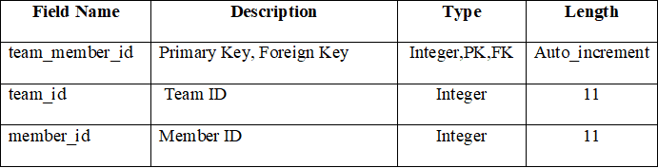
Table 14: Member Name Table of Online Alton Management System
Table of the Member
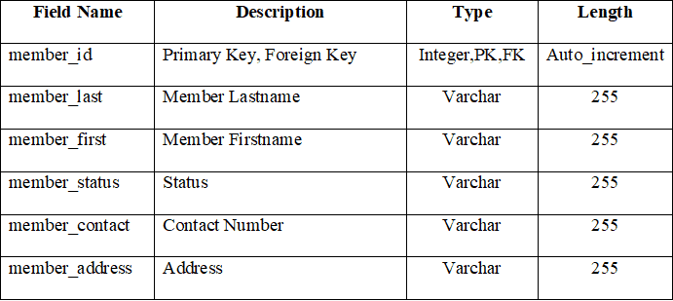

Table of the Event
Table 15: Event Table of Online Alton Management System
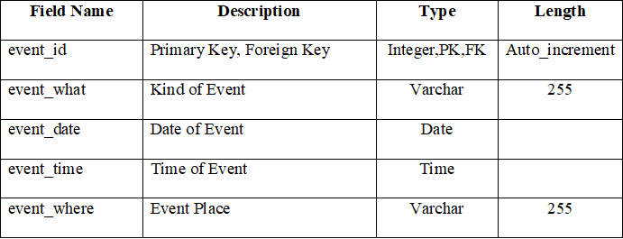

Table of the Accommodate
Table 16: Accommodate Table of Online Alton Management System
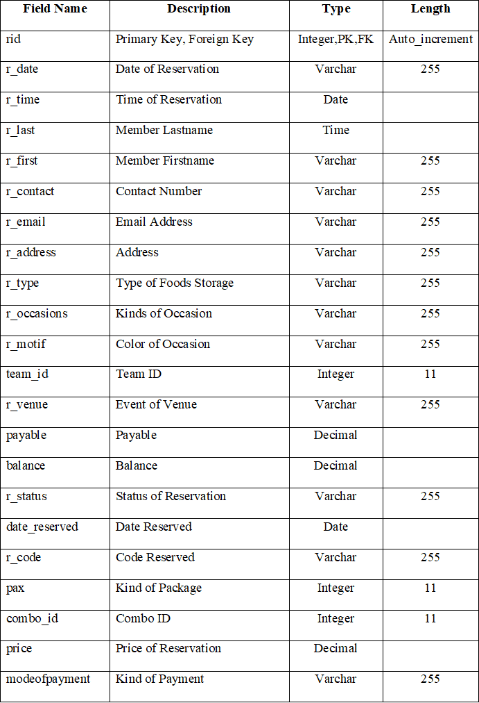

Table of the r_Noncombo
Table 17: r_Noncombo Table of Online Alton Management System
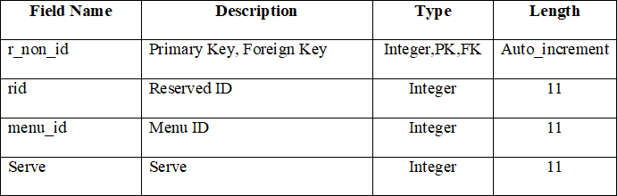

Table of the r_combo
Table 18: r_combo Table of Online Alton Management System
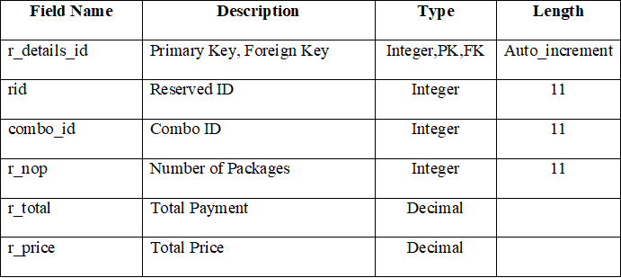

Table of the Message
Table 19: Messages Table of Online Alton Management System
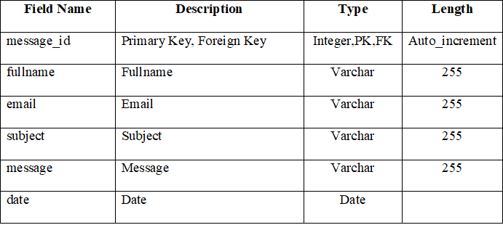
Table of the Payment
Table 20: Payment Table of Online Alton Management System
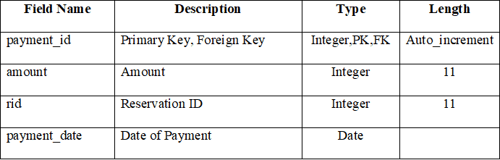

Table of the Announcement
Table 21: Announcement Table of Online Alton Management System
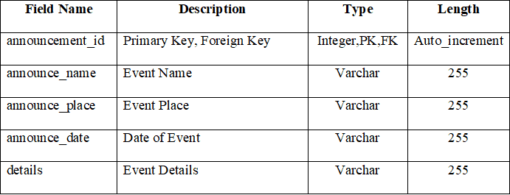

Architectural Framework
Architectural Diagram shows the process of Online Alton Management System. The user interacts with the system through a computer, every action made by the user such as typing or inputting words.
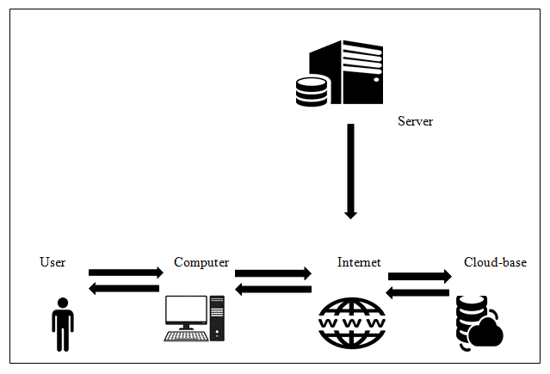Figure 17: Online Alton’s Management System Architectural Diagram
This show the interaction of the user, the computer, the internet, the cloud-based database and the server. The user accessed the system to the computer through an internet and the information comes from the cloud-based database that is uploaded by the server through an internet.

