Library Management System UML Diagrams
Here are the UML Diagrams that completes Library Management System. Each of the UML Diagrams has a major role in achieving a well-developed and functioning Library Management System.

Sequence Diagram for Library Management System
The Sequence Diagram for Library Management System represents the scenario and the messages that must be passed between objects. This is done in order for the scenario’s functionality to be realized. It’s an interaction diagram that shows how activities are carried out, including when and how messages are sent.
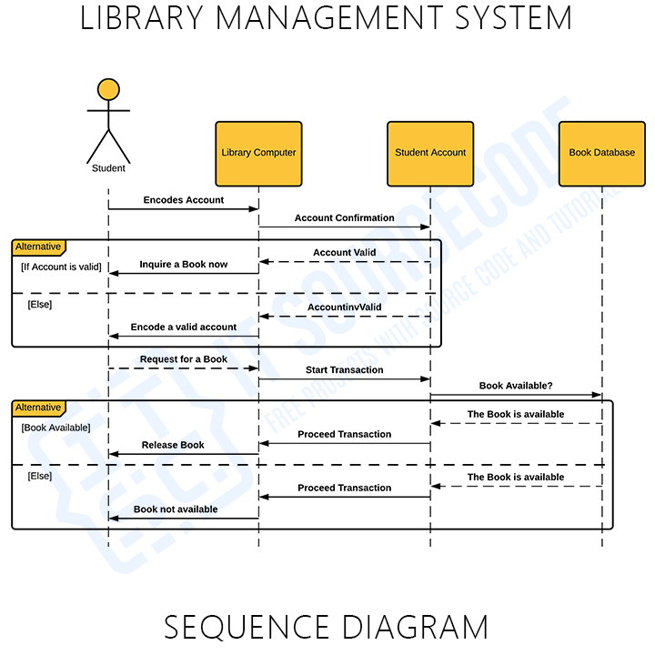
The sequence diagram given shows 4 objects which are: the student, library server (computer), account database, and book database. These objects were based on practical activities that happens in library management. The sequence of messages then was plotted below the objects to determine how the process is being performed.

Activity diagram for Library Management System
The Library Management System Activity Diagram is as one of the UML behavioral diagrams. It shows the system’s behavior by presenting the flow of activities from one to another. The possible flow of activities can be in order, split, or continuous.
Activity Diagram for Library Management System (Librarian) – This illustration shows the activities and scenarios done when the librarian accesses the system. The actions and decisions included were all emphasized here.
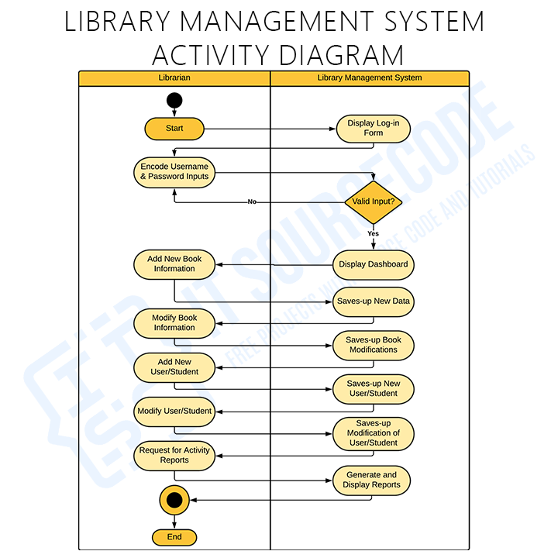
Library Management System Activity Diagram (for Students). This diagram now shows the series of scenarios while using the library management system. It illustrates the activities or events done when the system is in use. The system design is able to show you the functions for the student side.
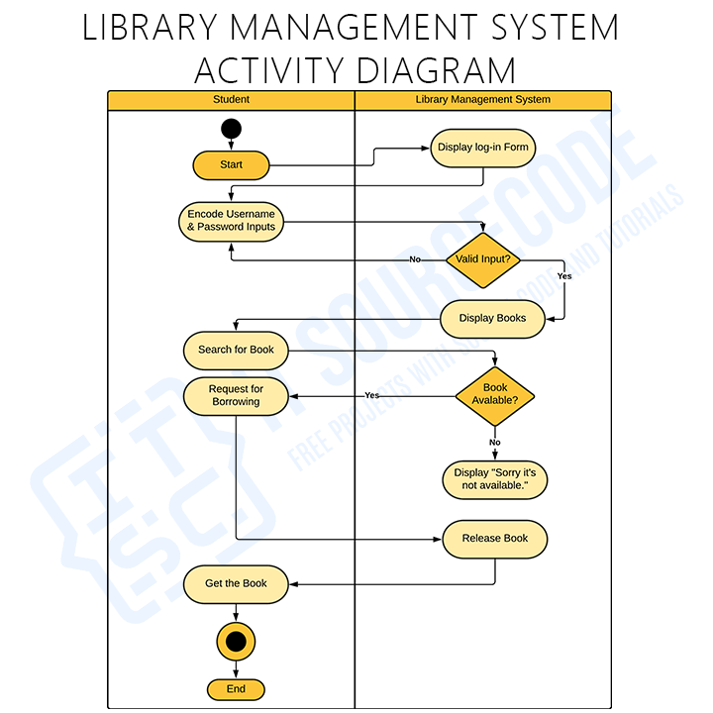

Class Diagram for Library Management System
A Library Management System Class Diagram is a form of structural (UML) diagram that depicts the structure of a system. This is designed by displaying the system’s classes, attributes, methods, and relationships between classes.
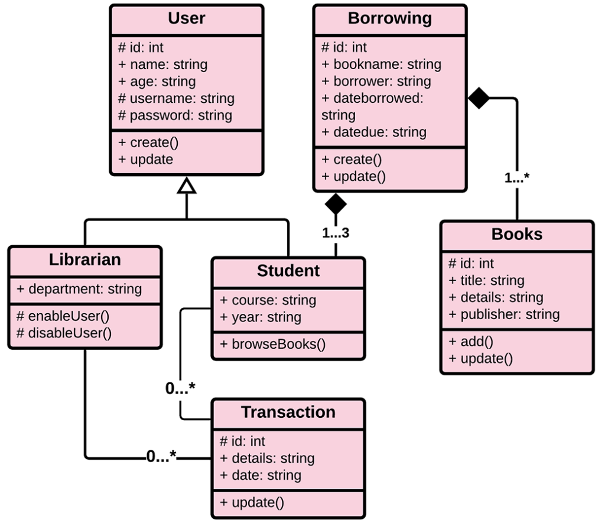
Class diagrams reveal the class structure blueprint of Library Management System. It is used to model the items that make up the system and depict their relationships. This is to define the function of an object and the operation it provides.

Use Case Diagram for Library Management System
The Library Management System Use Case Diagram is a graphic summary of the software and user details. It’s usually depicted as a graphical representation of the entities’ interactions.
The General Use Case Diagram of Library Management System contains the main use cases and users in the system. These use cases will be elaborated in the following diagrams.
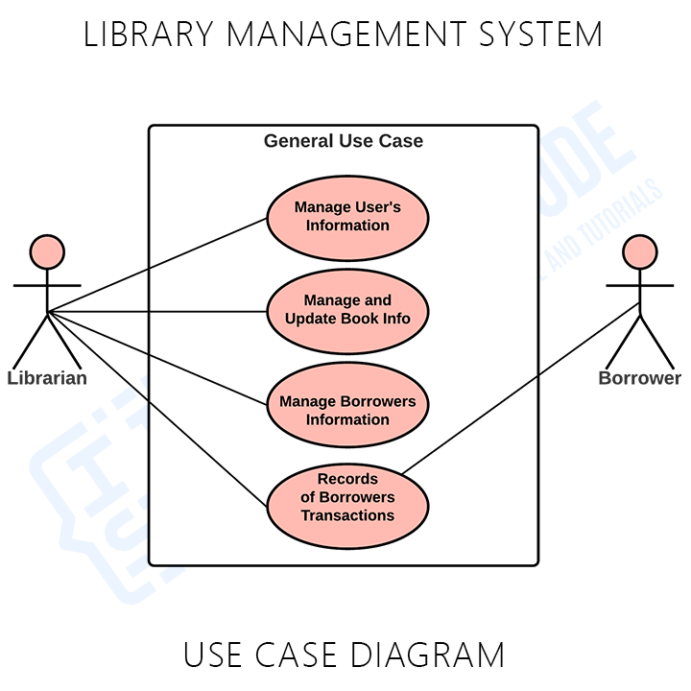Library Management System General Use Case
The diagram shows the main use cases in Library management. The use cases are the User’s information management, Book information management and updates, borrower’s management and management of transaction records.
Use Case Diagram for Library Management System using Include and Extend (Manage User’s Information). This diagram focuses mainly on the use case “Manage User’s Information”. It includes the sub-processes which are pre-requisite to complete user’ information management.
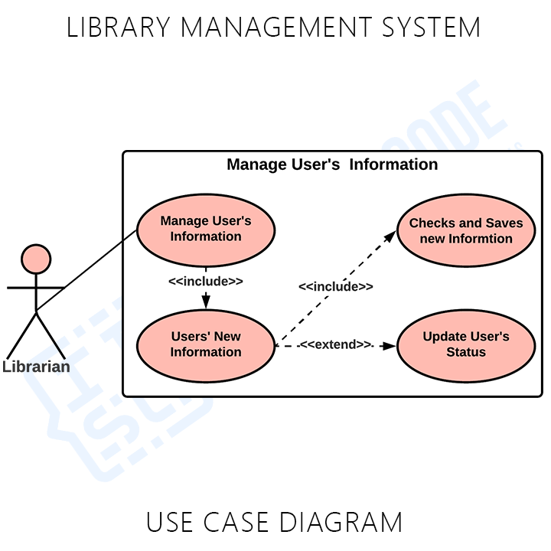Library Management System Use Case Diagram
The presented use case diagram explains the included processes when managing user’s information. The processes with <<include>> indicator was the “Users New Information” and “Checks and Saves the New Information”. That means they must be included in the main process and the other process “Update Users Status” is only done when needed.
Use Case Diagram for Library Management System using Include and Extend (Manage and Update Book Info). This diagram focuses on the use case “Manage and Update Book Information”. It includes the sub-processes which are pre-requisite to complete Book’s information management and update.
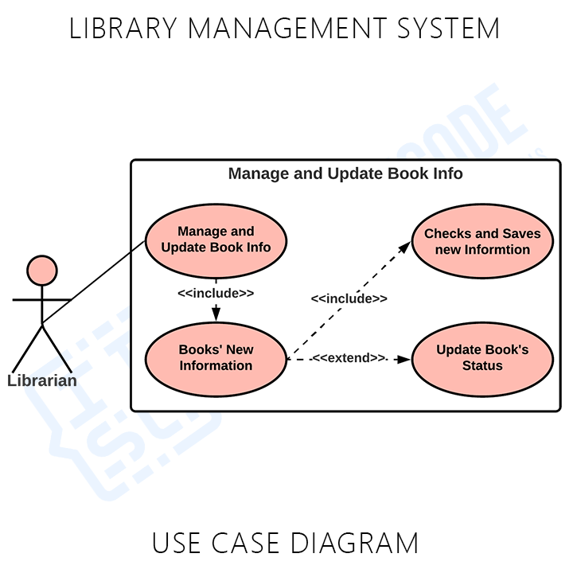
Another presented use case diagram explains the included processes when managing and updating book information. The processes with <<include>> indicator was the “Book’s New Information” and “Checks and Saves the New Information”. That means they must be included in the main process and the other process “Update Book Status” is only done when needed
Use Case Diagram for Library Management System using Include and Extend (Manage Borrowers Information). This diagram focuses on the use cases “Manage Borrowers Information”. It includes the sub-processes which are pre-requisite to complete Borrowers’ information management and update.
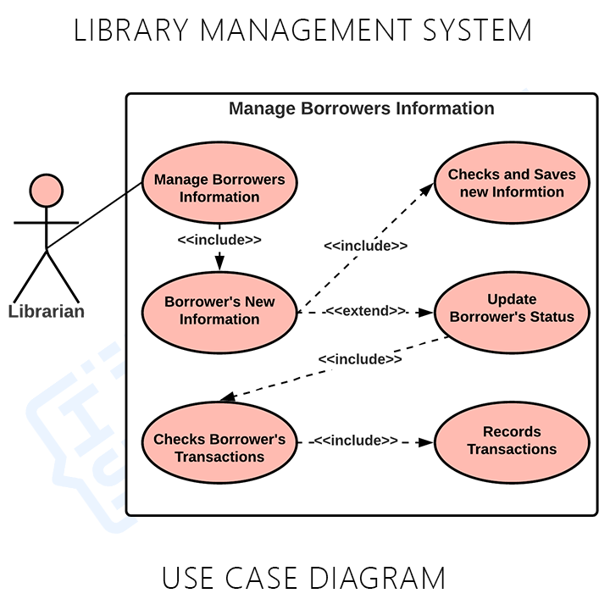Library Management System Use Case Diagram Borrower’s Info
Another presented use case diagram explains the included processes when managing and updating borrower’s information. The processes with <<include>> indicator was the “Borrower’s New Information” and “Checks and Saves the New Information”. That means they must be included in the main process.
You can see that the next process is labeled <<extend>> because it is a conditional process. The sub use case “Update Borrower’s Status” is only performed when needed. Then this process invokes the must be done cases such as “Checking of Borrower’s Transaction” and “Recording of Transaction”.

Bonus Diagrams for Library Management System

Data Flow Diagram for Library Management System
The Library Management System DFD represents the “flow” of data in all processes present in Library Management. This DFD for Library Management System is also known as Data Flow Diagram. Its diagram has three levels that elaborates the overall data flow.
DFD Level 0 shows the entities that interact with the system. It defines the border between the system and its environment. This context diagram depicts Library Management Project at a high level.
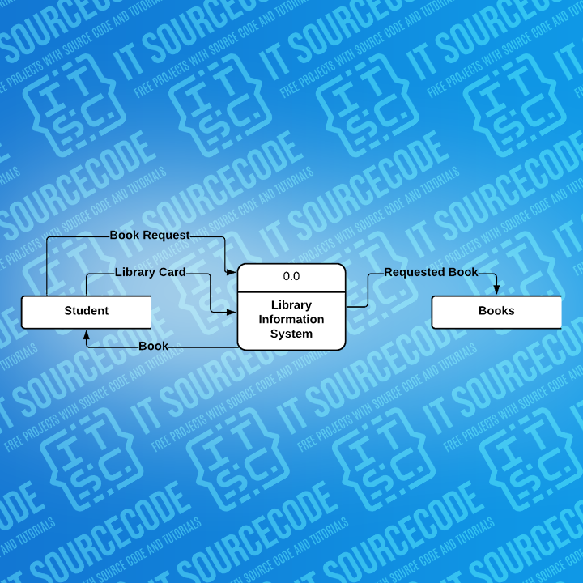Library Management System DFD – Level 0
The illustration presents the main process in a single node to introduce the project context. This context is explaining how the project work in just one look. The users feed data into the system and then receives the output from it.
The DFD Level 1 shows the wider details of Library DFD Level 0. This is to clarify the paths (flow) of data and its transformation from being an input to an output. The designed diagram portrays two different scenario which is the Book Delivery and the topic search.
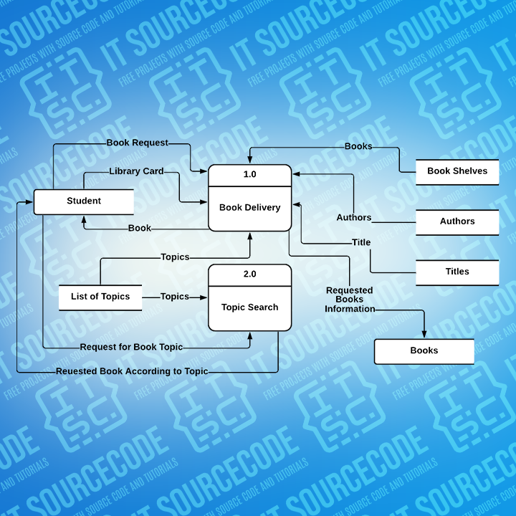Library Management System DFD – Level 1
The flow of data starts from the student giving the borrowing request and his/her information. The system then caters the information and process the request. By that, the processes generate the data flow and transformation until it reaches the desired output.
Level 2 DFD for Library Management System is also called as the highest abstraction of data flow diagram. This level also broadens the idea from the DFD level 1. It includes the sub-processes from level 1 as well as the data that flows.
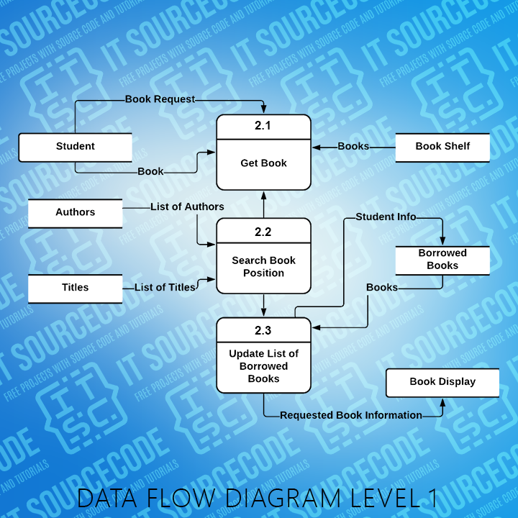Data Flow Diagram (DFD) Level 2 for Library Management System
This diagram has elaborated the sub-processes derives from “topic search” process. The sub-processes were get book, search book position, and update. These processes were invoked by the book borrower and then catered by the system.

ER Diagram for Library Management System
The College Library Management System ER Diagram reveals the relationships between college library entity sets in a database. This displays the logical structure of databases. It is done by identifying entities, their properties, and the interactions between them.
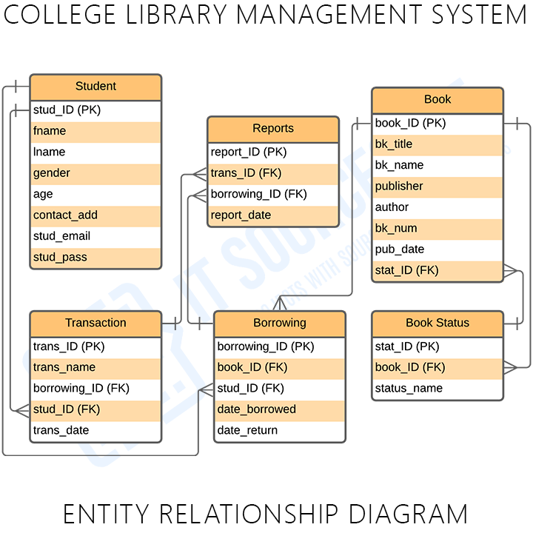
This diagram presents the Entities’ Relationship Model for College Library Management System. It is used to enlighten you with how the back end or the database of the project works. The tables are made to meet the required specification of the system and provide much more specific details of each entity within the system.

